**LAB EXPERIMENTS OUTPUT / SCREEN SHOTS**

# COURSE CODE : CSA1503

**COURSE : CLOUD COMPUTING AND**

**BIG DATA ANALYTICS FOR INTERNET OF THINGS**

**SLOT : D**

**NAME : A. BHARATH KUMAR**

**REG. NO: 192211985**

**SL.No: 2**

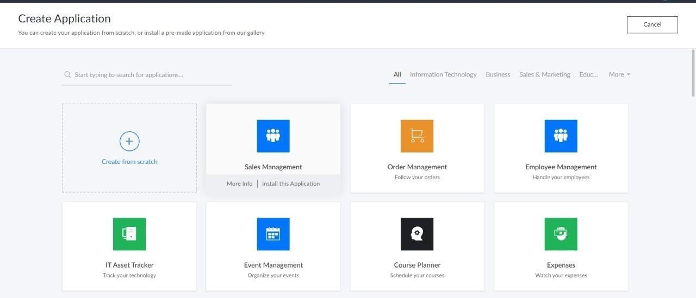

**EX. NO ; 1**

**CREATE**

**A**

**SIMPLE**

**CLOUD**

**SOFTWARE**

**APPLICATION**

**AND**

**PROVIDE IT**

**AS**

**A**

**SERVICE USING**

**ANY CLOUD SERVICE PROVIDER**

**TODEMONSTRATE SOFTWARE AS A SERVICE (SAAS).**

**DATE OF EXPERIMENT:**

**16**

**-**

**09**

**-**

**2024**

**AIM ;**

To

create

a

simple

cloud

software

application

and

provide

it

as

a

service

using any

cloud service provider to demonstrate software

as

a

service (saas).

**SCREEN SHOTS AND OUTPUT:**

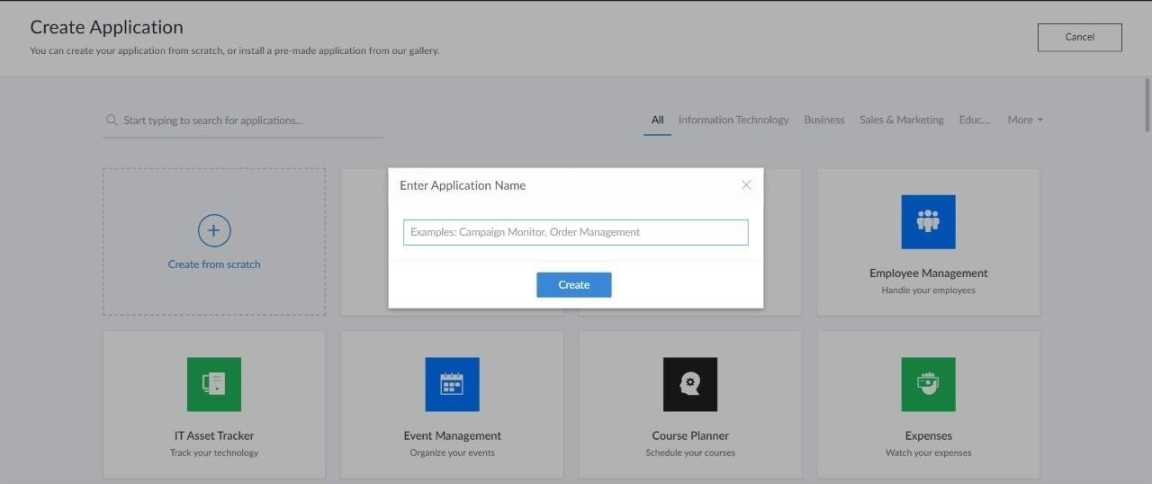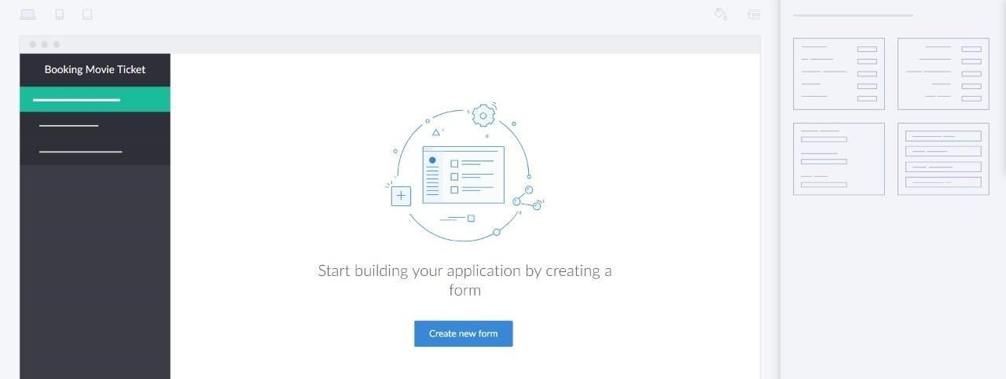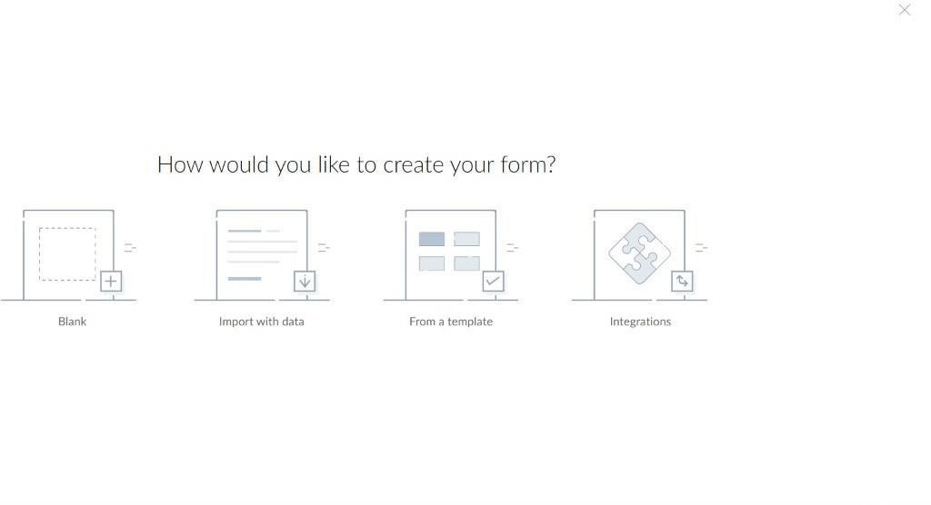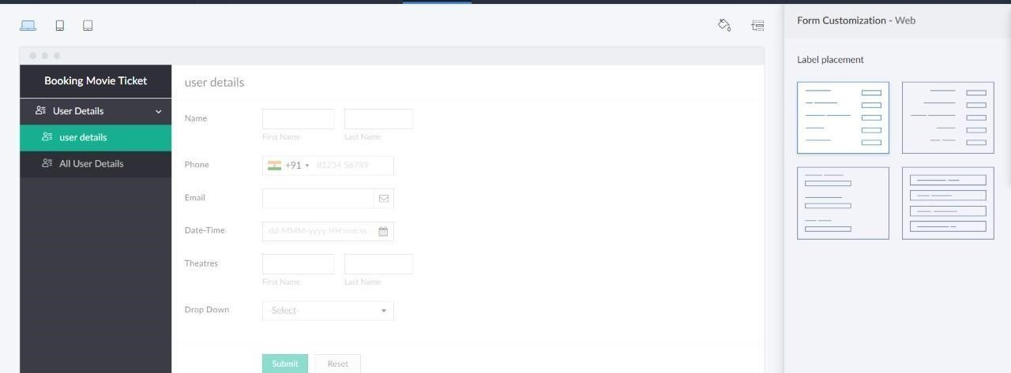

**EX. NO ;**

**2**

**CREATE**

**A**

**SIMPLE**

**CLOUD**

**SOFTWARE**

**APPLICATION**

**FOR**

**FLIGHT**

**RESERVATION SYSTEM USING ANY CLOUD SERVICE PROVIDER TO DEMONSTRATE SAAS**

.

**DATE OF EXPERIMENT:**

**16**

**-**

**09**

**-**

**2024**

**AIM ;**

To

create

a

simple

cloud

software

application

for

flight

reservation

system

using

any

cloud

service

provider

to

demonstrate

saas.

**SCREEN SHOTS AND OUTPUT:**

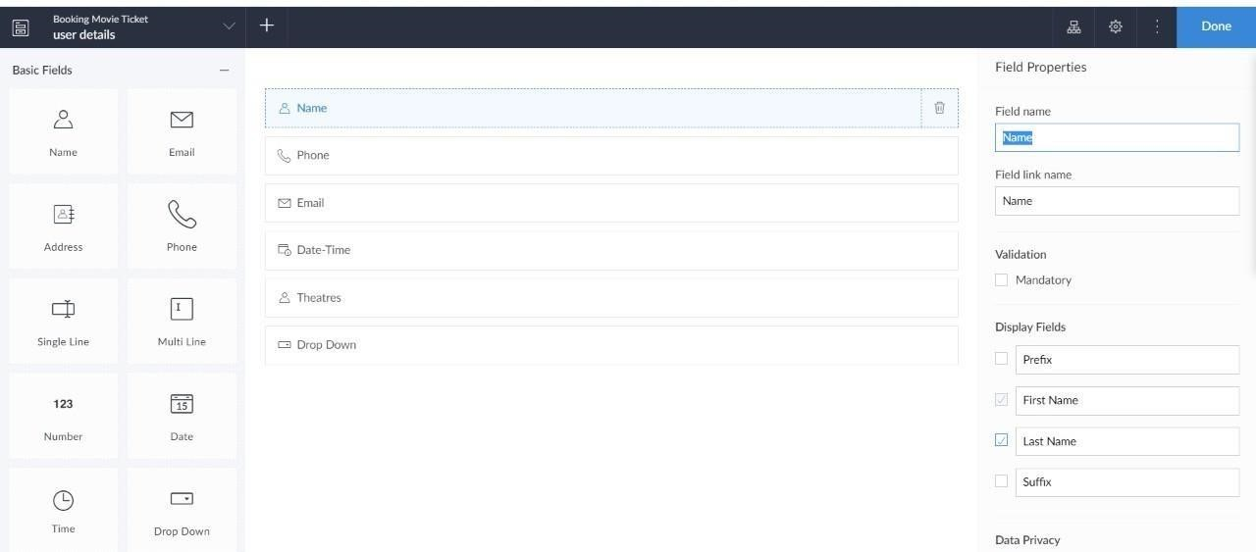















**EXP NO 3: CREATE A SIMPLE CLOUD SOFTWARE APPLICATION FOR PROPERTY BUYING & RENTAL PROCESS (IN CHENNAI CITY) USING ANY CLOUD SERVICE PROVIDER TO DEMONSTRATE SAAS. DATE: 16-09-2024 AIM:**

To Create a simple cloud software application for Property Buying & Rental process (In Chennai city) using any Cloud Service Provider to demonstrate SaaS.

**SCREEN SHOTS AND OUTPUT:**

















**EXP NO 4: CREATE A SIMPLE CLOUD SOFTWARE APPLICATION FOR CAR BOOKING RESERVATION SYSTEM USING ANY CLOUD SERVICE PROVIDER TO DEMONSTRATE SAAS.**

**DATE: 16-09-2024 AIM:**

To Create a simple cloud software application for Car Booking Reservation System using any Cloud Service Provider to demonstrate SaaS.

**SCREEN SHOTS AND OUTPUT:**

















**EXP NO 5: CREATE A SIMPLE CLOUD SOFTWARE APPLICATION FOR**

**LIBRARY BOOK RESERVATION SYSTEM FOR SIMATS LIBRARY USING**

**ANY CLOUD SERVICE PROVIDER TO DEMONSTRATE SAAS**

**DATE: 16-09-2024 AIM:**

To Create a simple cloud software application for Library book reservation system for

SIMATS library using any Cloud Service Provider to demonstrate SaaS

**SCREEN SHOTS AND OUTPUT:**











**.**





**EXP NO 6: CREATE A SIMPLE CLOUD SOFTWARE APPLICATION FOR PRODUCT SELLING USING ANY CLOUD SERVICE PROVIDER TO DEMONSTRATE SAAS.**

**DATE: 16-09-2024 AIM:**

To create a simple cloud software application for product selling using any cloud service provider to demonstrate saas.

**SCREEN SHOTS AND OUTPUT:**

















**EXP NO 7: DEMONSTRATE VIRTUALIZATION BY INSTALLING TYPE-2 HYPERVISOR IN YOUR DEVICE, CREATE AND CONFIGURE VM IMAGE WITH A HOST OPERATING SYSTEM (EITHER WINDOWS/LINUX).**

**DATE:** **17-09-2024 AIM:**

To demonstrate virtualization by installing type-2 hypervisor in your device, create and configure VM image with a host operating system (either windows/linux).

**SCREEN SHOTS AND OUTPUT:**

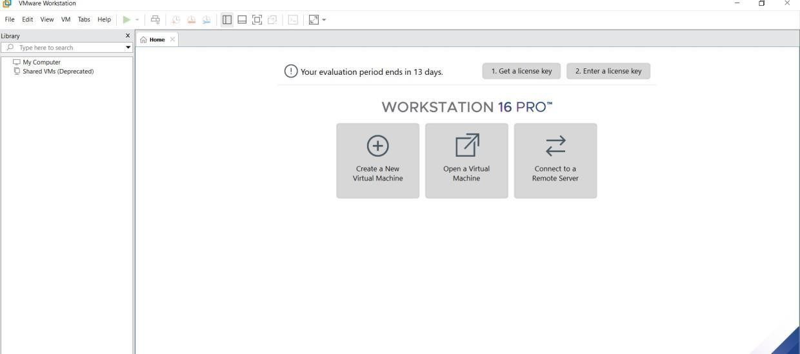

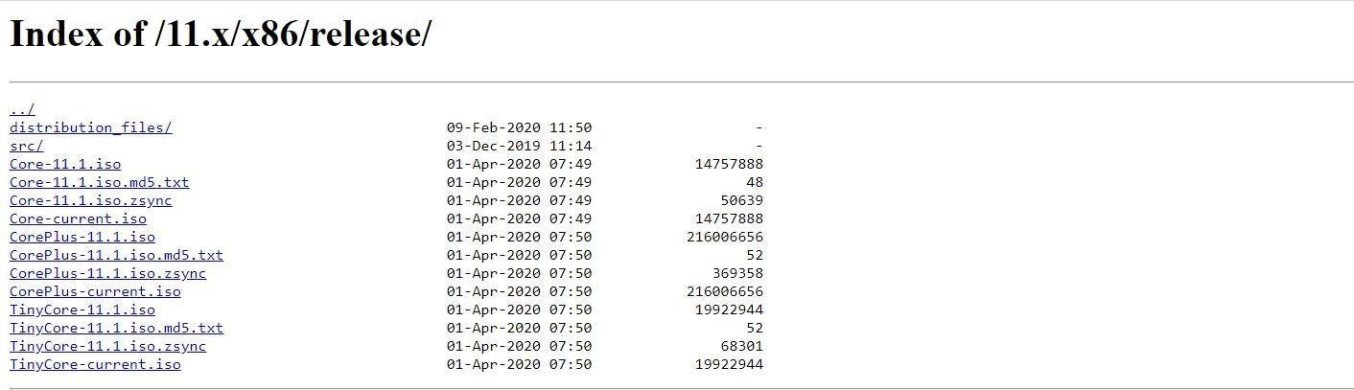

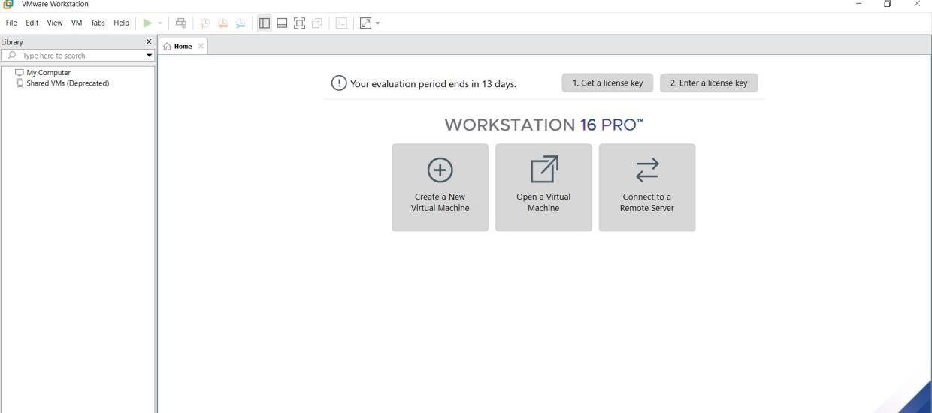

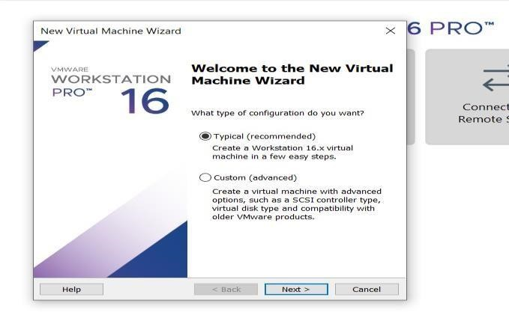

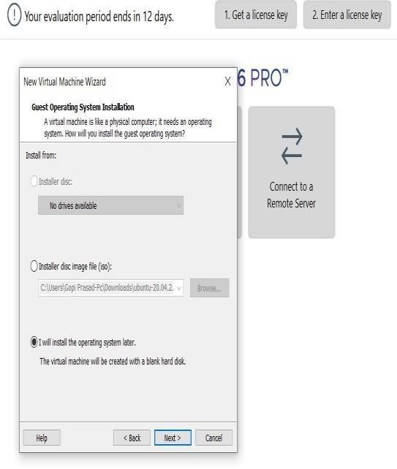

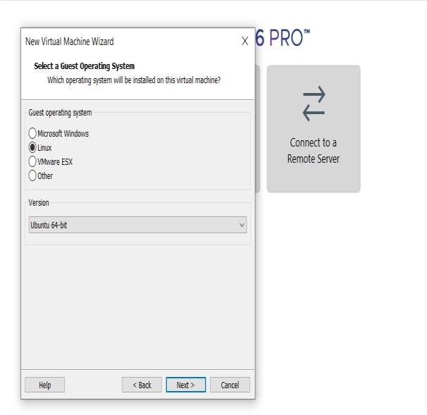

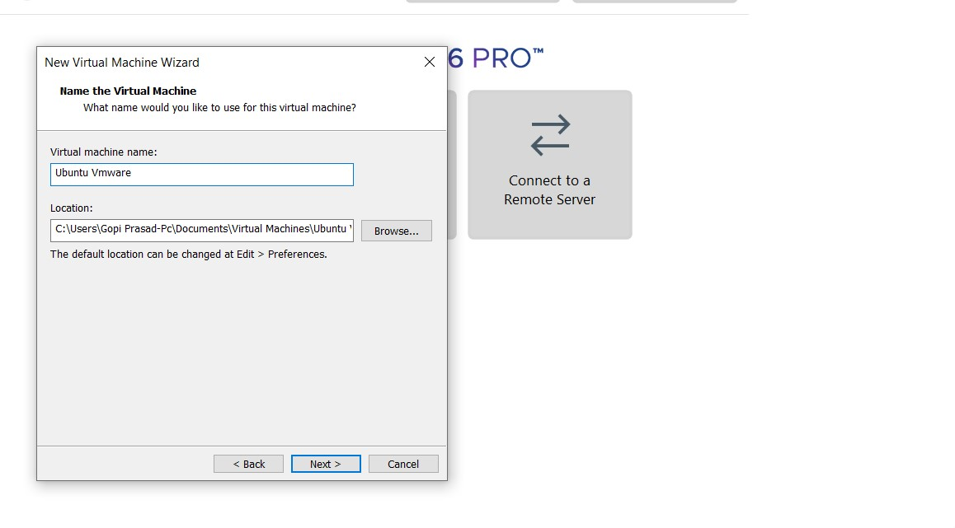

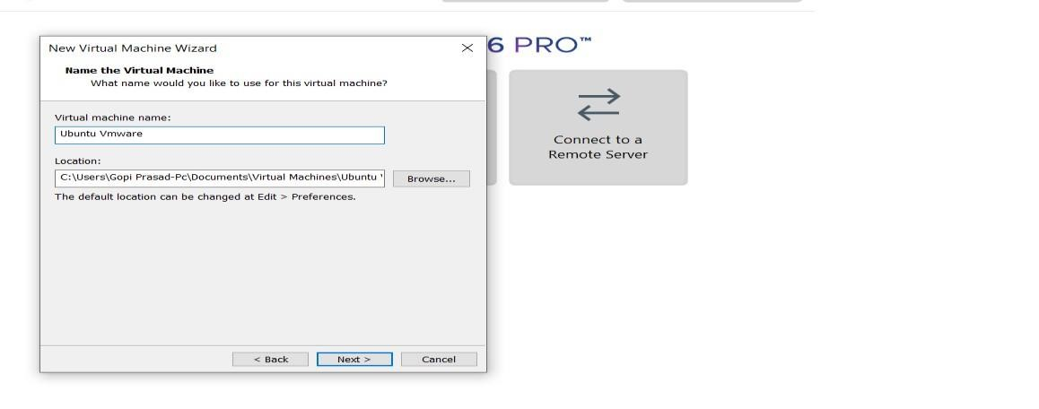

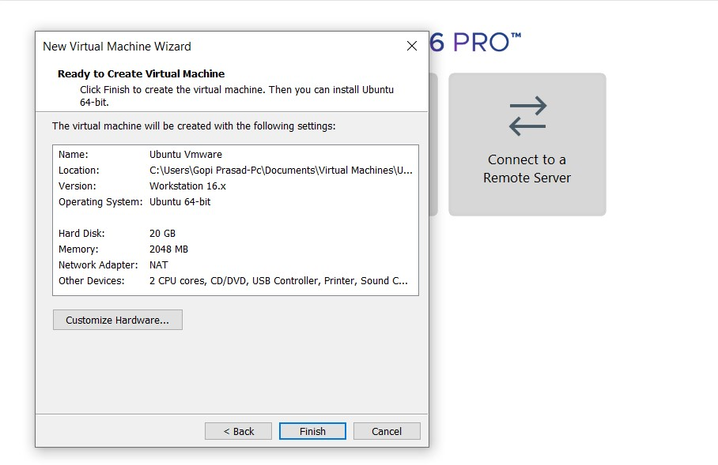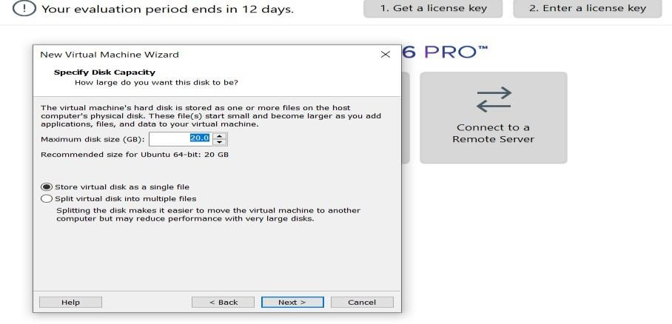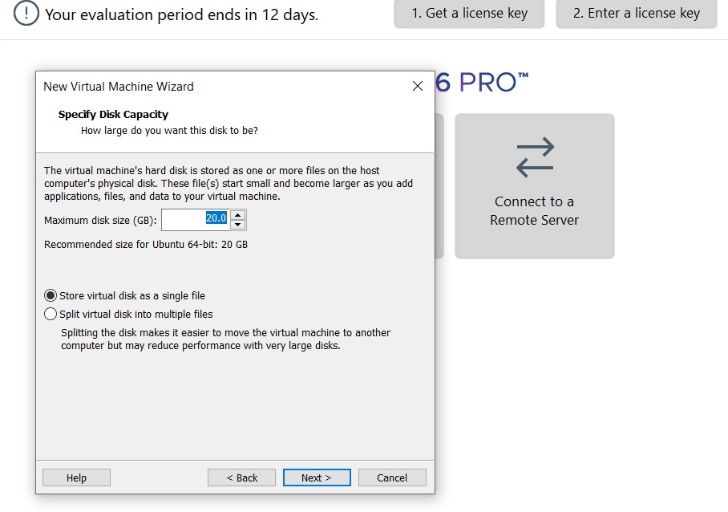

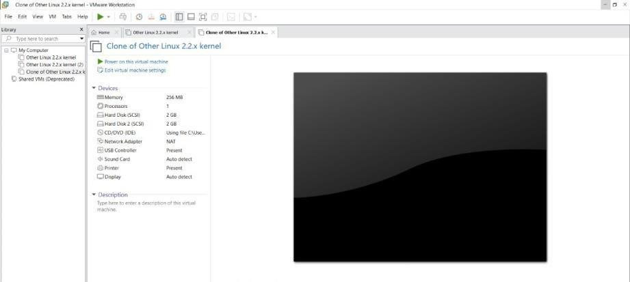

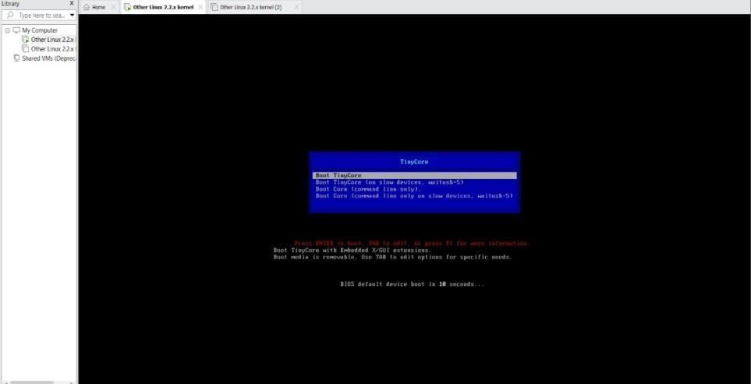

**EXPNO 8: CREATE A VIRTUAL MACHINE WITH 1 CPU, 2GB RAM AND 15GB STORAGE DISK USING A TYPE 2 VIRTUALIZATION SOFTWARE.**

**DATE: 17-09-2024**

**AIM:**

To create a virtual machine with 1 cpu, 2gb ram and 15gbstorage disk using a type 2 virtualization software**.**

**SCREEN SHOTS AND OUTPUT:**





















**EXP 9: CREATE A VIRTUAL HARD DISK AND ALLOCATE THE STORAGEUSING VM WARE WORKSTATION. DATE: 17-09-2024**

**AIM:**

To create a virtual hard disk and allocate the storage using vm ware workstation

**Screenshots and output:**

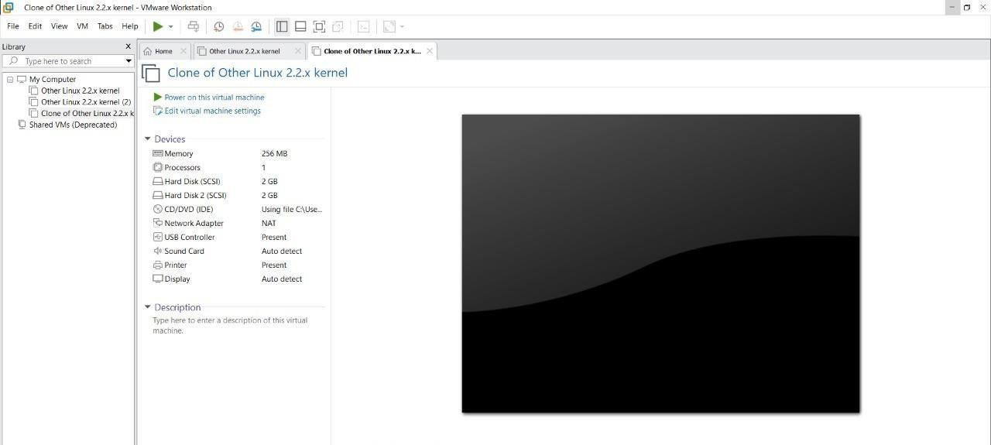

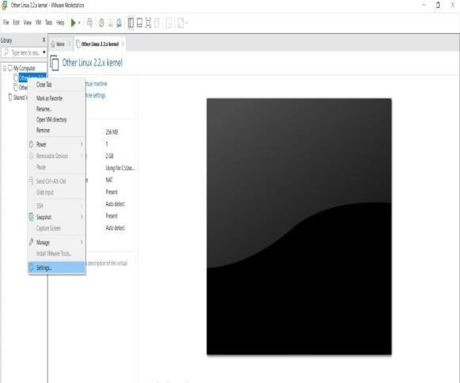

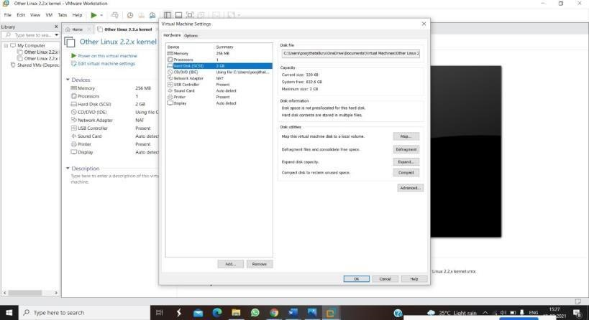

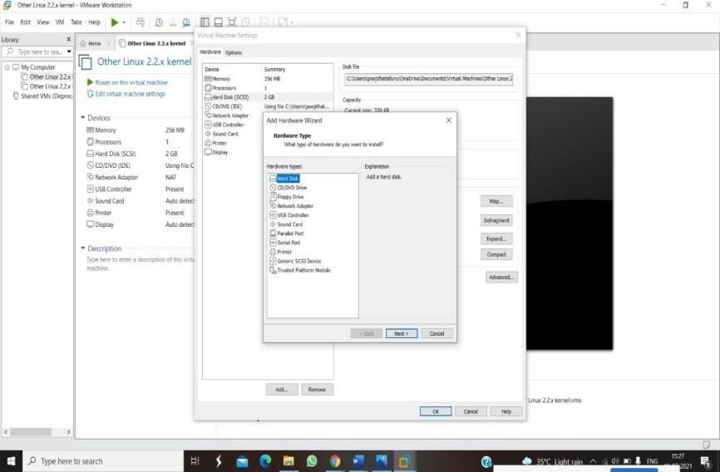

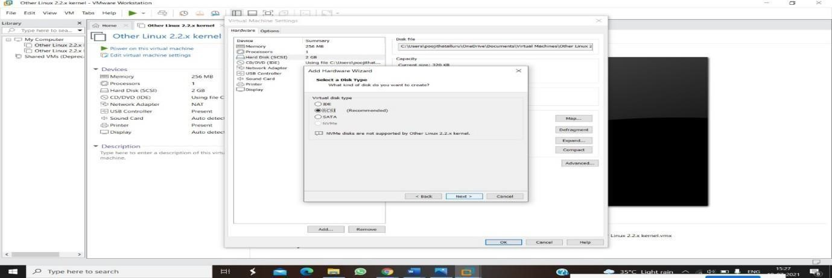

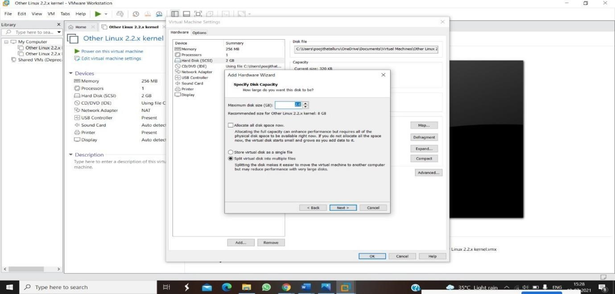

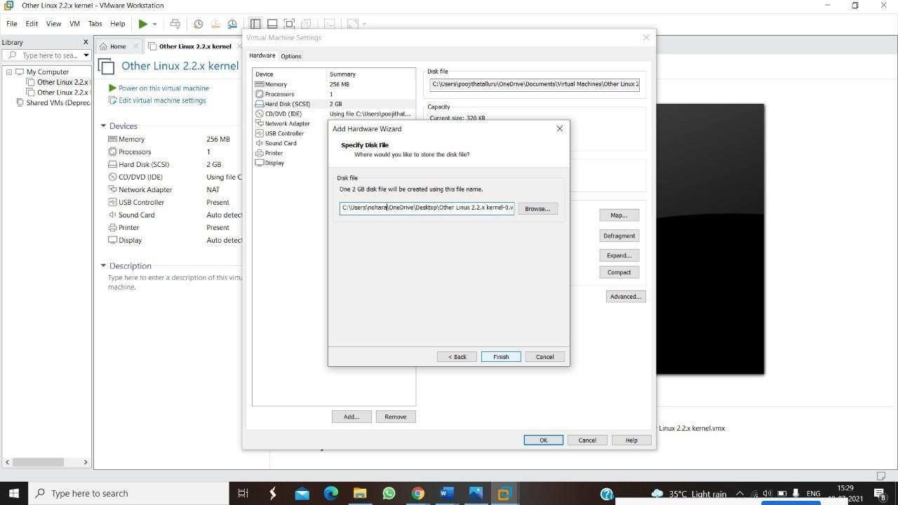

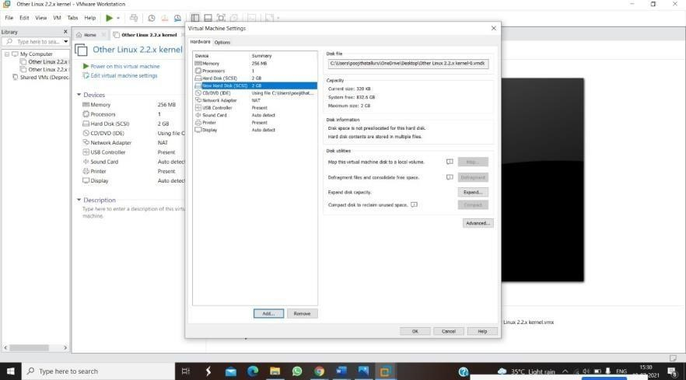

**EXPNO 10: CREATE A SNAPSHOT OF A VM AND TEST IT BY LOADING THE PREVIOUS VERSION/CLONED VM DATE: 17-09-2024**

**AIM:**

To create a snapshot of a vm and test it by loading the previous version/cloned vm

**Screenshots and outputs:**

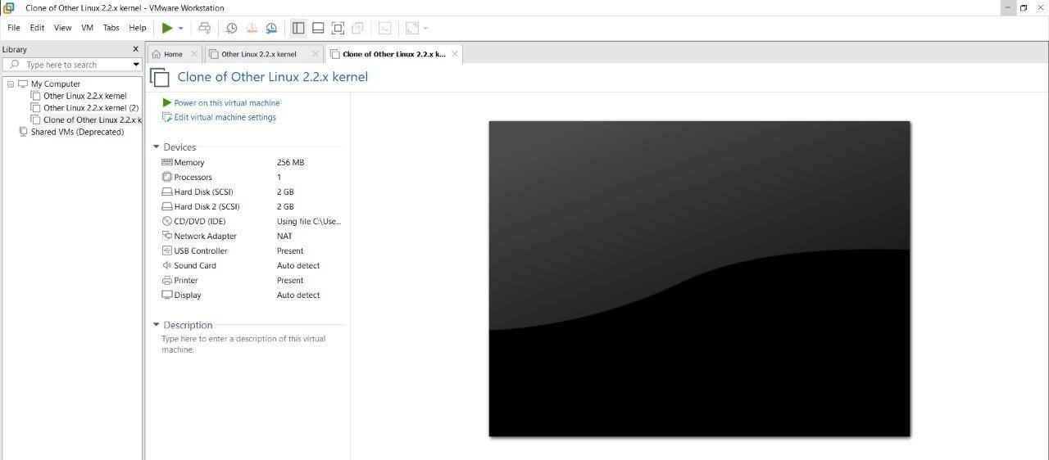

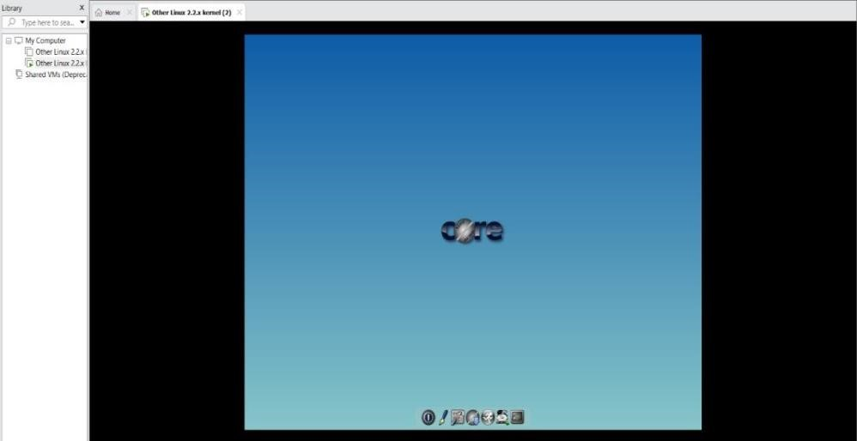

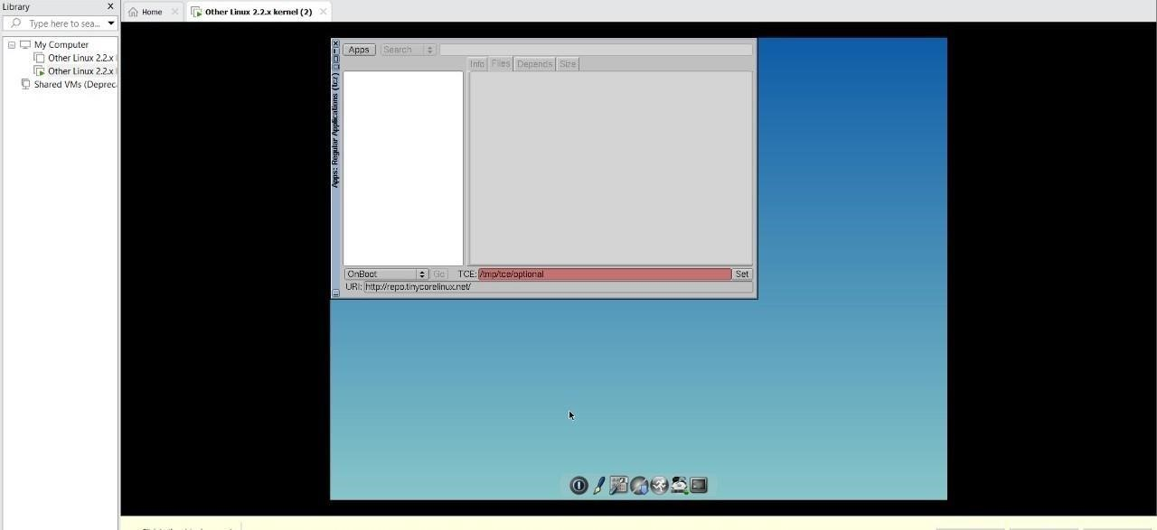

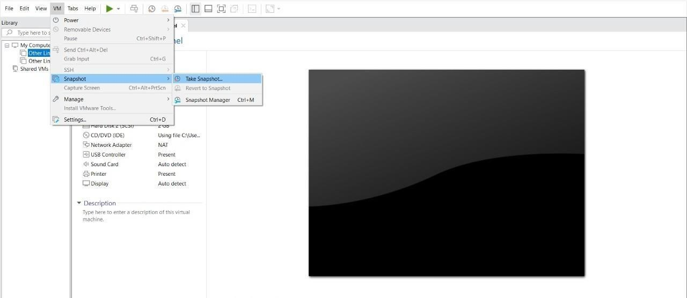

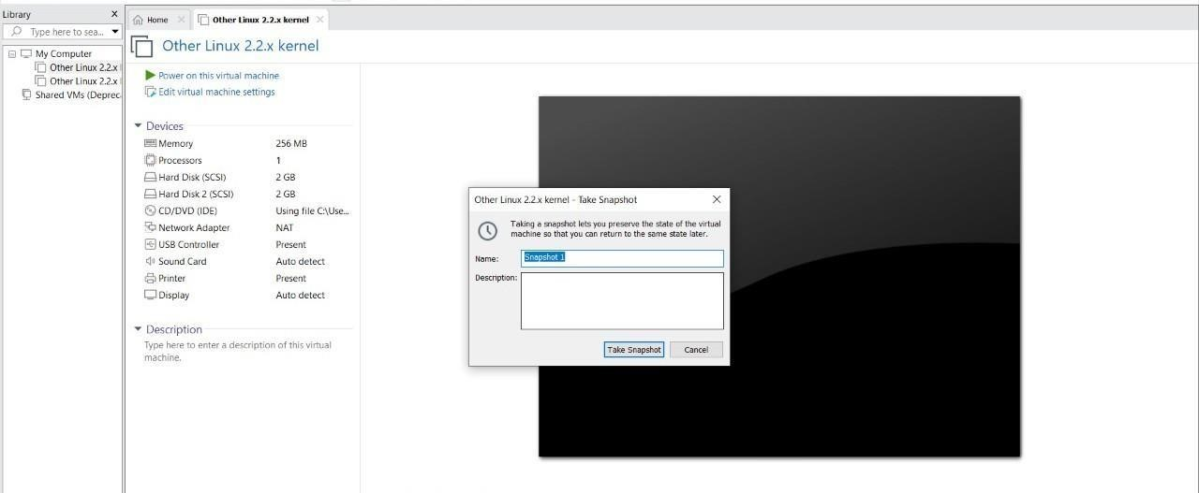

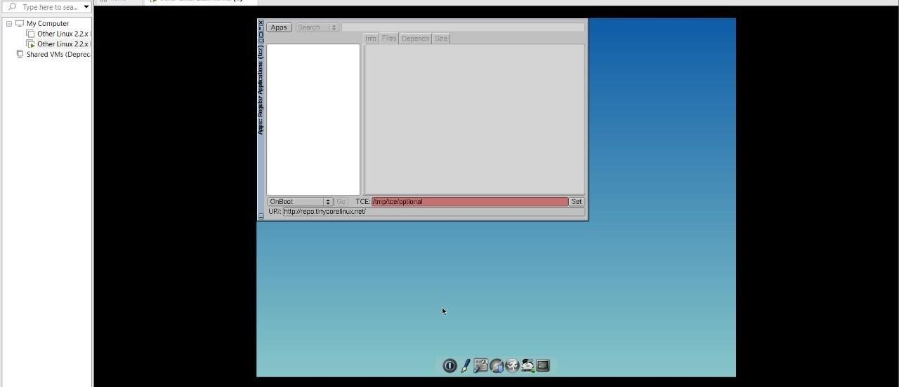

**EXPNO 11: CREATE A CLONING OF A VM AND TEST IT BY LOADING THE PREVIOUS VERSION/CLONED VM.**

**DATE: 17-09-2024**

**AIM:**

To create a cloning of a vm and test it by loading the previous version/cloned vm.

**Screenshots and outputs:**

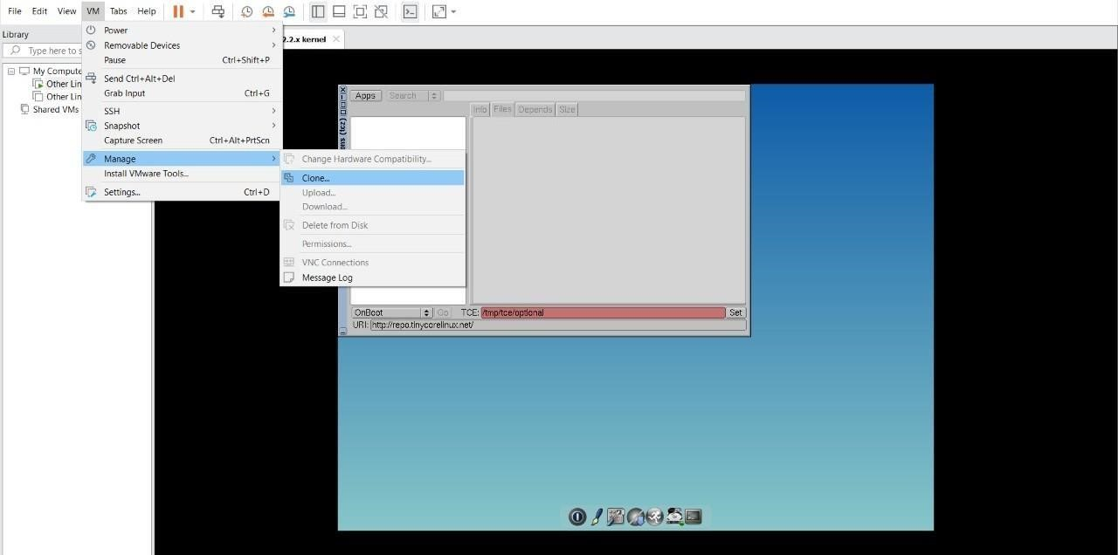

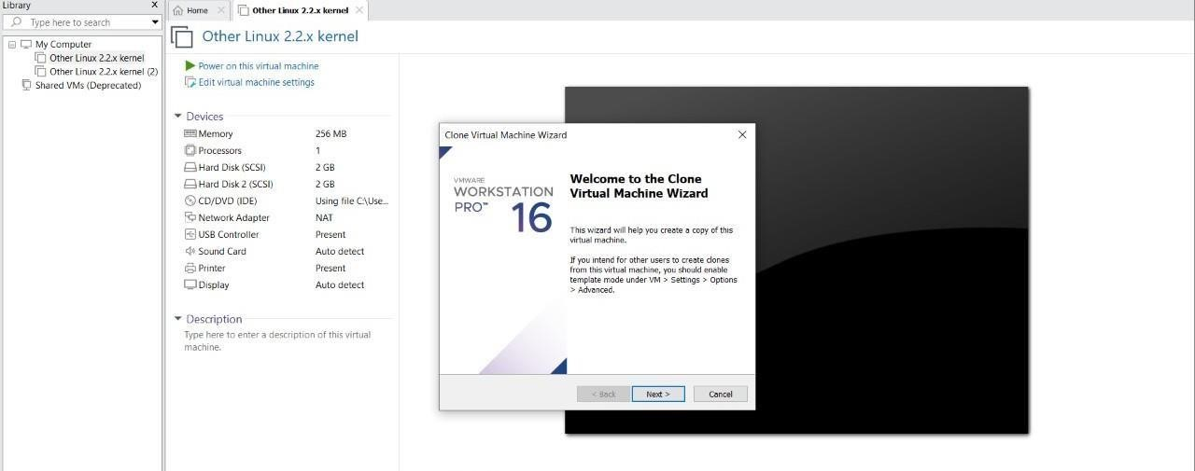

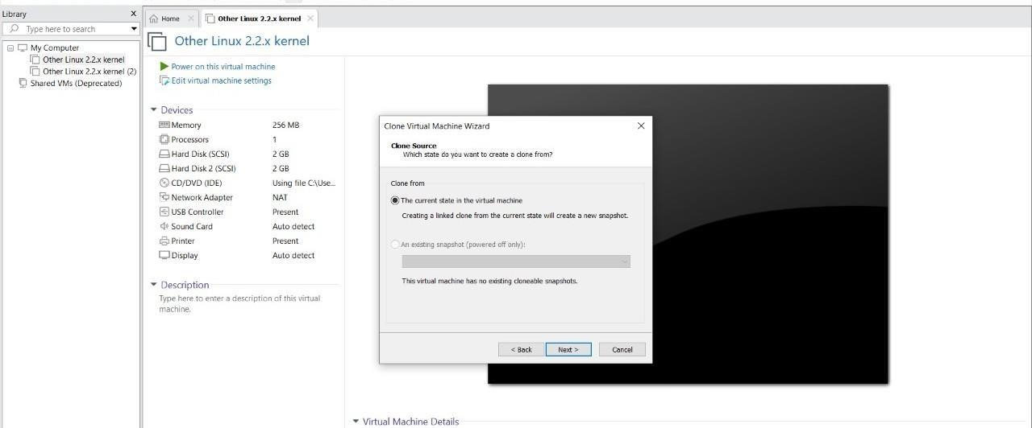

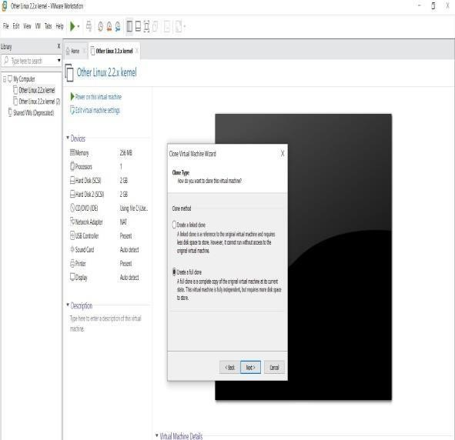

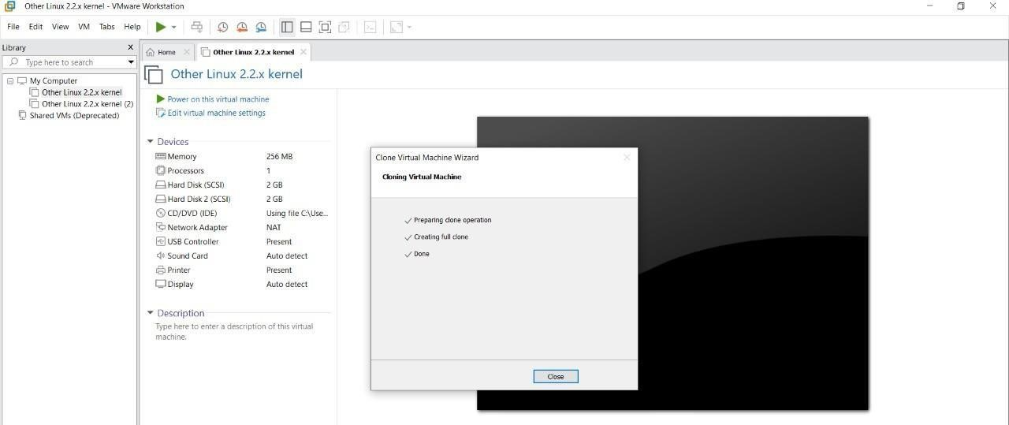

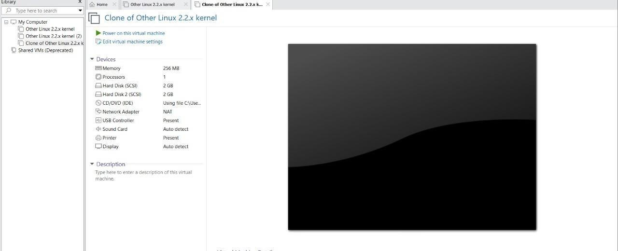

**EXP 12: CHANGE HARDWARE COMPATIBILITY OF A VM (EITHER BY CLONE/CREATE NEW ONE) WHICH IS ALREADY CREATED AND CONFIGURED.**

**DATE: 17-09-2024**

**AIM:**

To Change Hardware compatibility of a VM (Either by clone/create new one) which is already created and configured.

**Screenshots and Outputs:**

















**EXP13. DEMONSTRATE INFRASTRUCTURE AS A SERVICE (IAAS)**

**BY CREATING A VIRTUAL MACHINE USING A PUBLIC CLOUD SERVICE PROVIDER (AZURE), CONFIGURE WITH REQUIRED MEMORY AND CPU.**

**Date:18-09-2024**

**AIM:**

To demonstrate infrastructure as a service (iaas) by creating a virtual machine using a public cloud service provider (azure), configure with required memory and cpu.

**Screenshots and Outputs:**

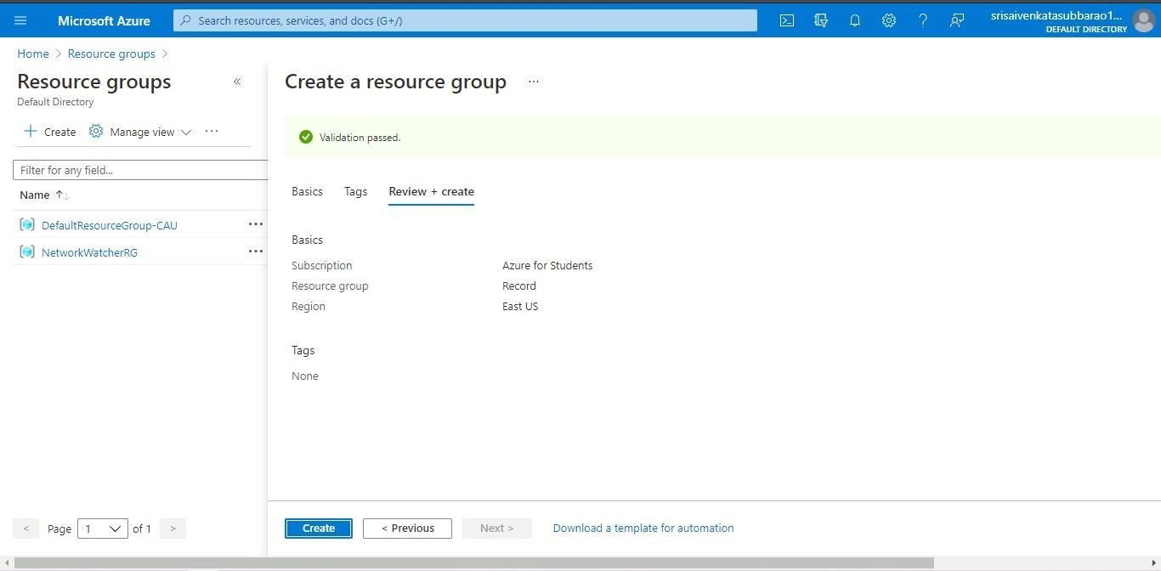

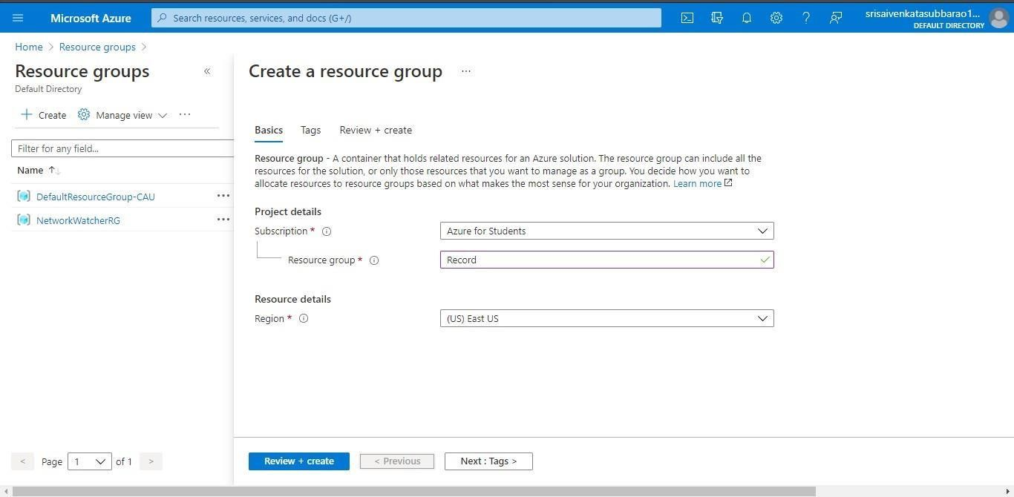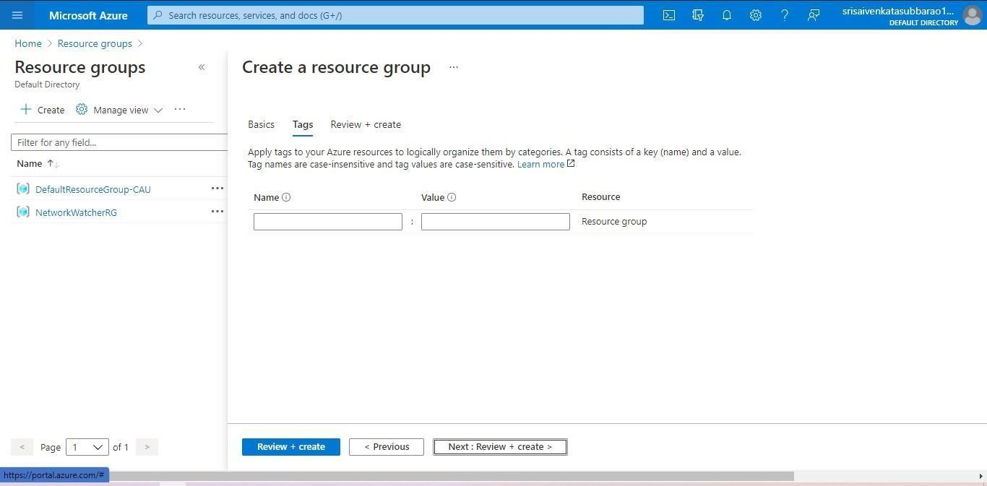

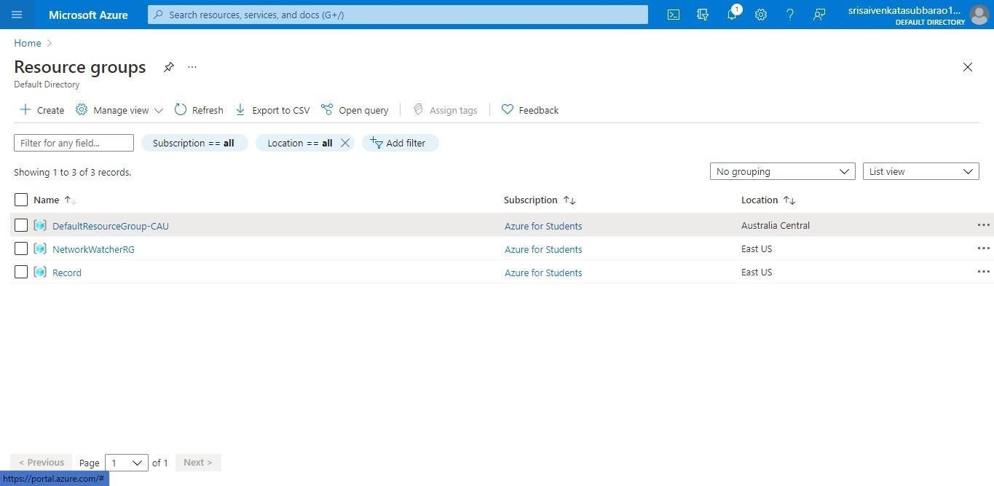

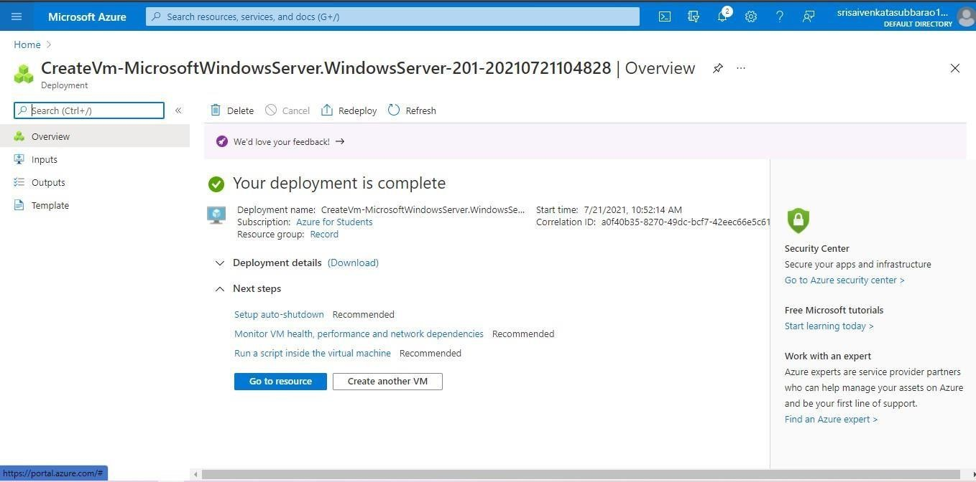

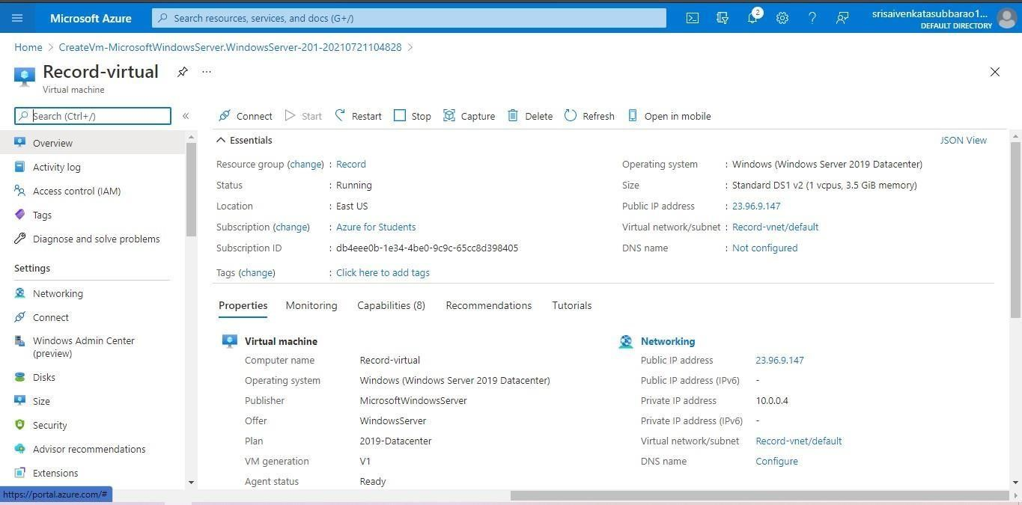



**EXP 17 .DEMONSTRATE INFRASTRUCTURE AS A SERVICE(IAAS) BY CREATING AVIRTUAL MACHINE USING A PUBLIC CLOUD SERVICE PROVIDER(AZURE/GCP/AWS) CONFIGURE WITH MINIMUM CPU, RAM ANDSTORAGE AND LAUNCH THE VM IMAGE. Date:18-09-2024 AIM:**

To demonstrate infrastructure as a service(iaas) by creating a virtual machine using a public cloud service provider(azure/gcp/aws) configure with minimum cpu,ram and storage and launch the vm image.

**Screenshots and outputs:**













**EXP15.CREATE A SIMPLE WEB SITE USING ANY PUBLIC CLOUD SERVICE PROVIDER (AZURE/GCP/AWS) AND CHECK THE PUBLIC ACCESSIBILITY OFTHE STORED FILE TO DEMONSTRATE STORAGE AS A SERVICE**

**Date:19-09-2024**

**AIM:** CREATE A SIMPLE WEB SITE USING ANY PUBLIC CLOUD SERVICE PROVIDER (AZURE/GCP/AWS) AND

CHECK THE PUBLIC ACCESSIBILITY OFTHE STORED FILE TO DEMONSTRATE STORAGE AS A SERVICE

**Screenshots and Outputs:**

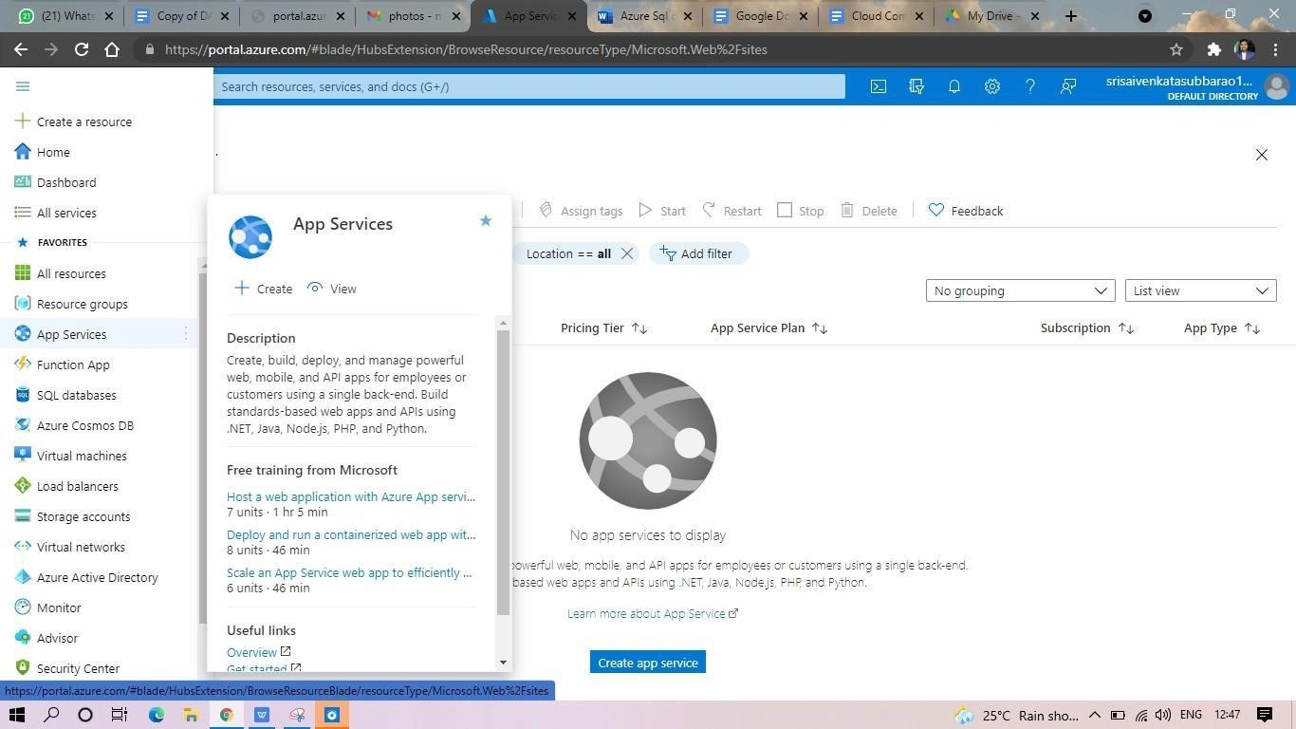

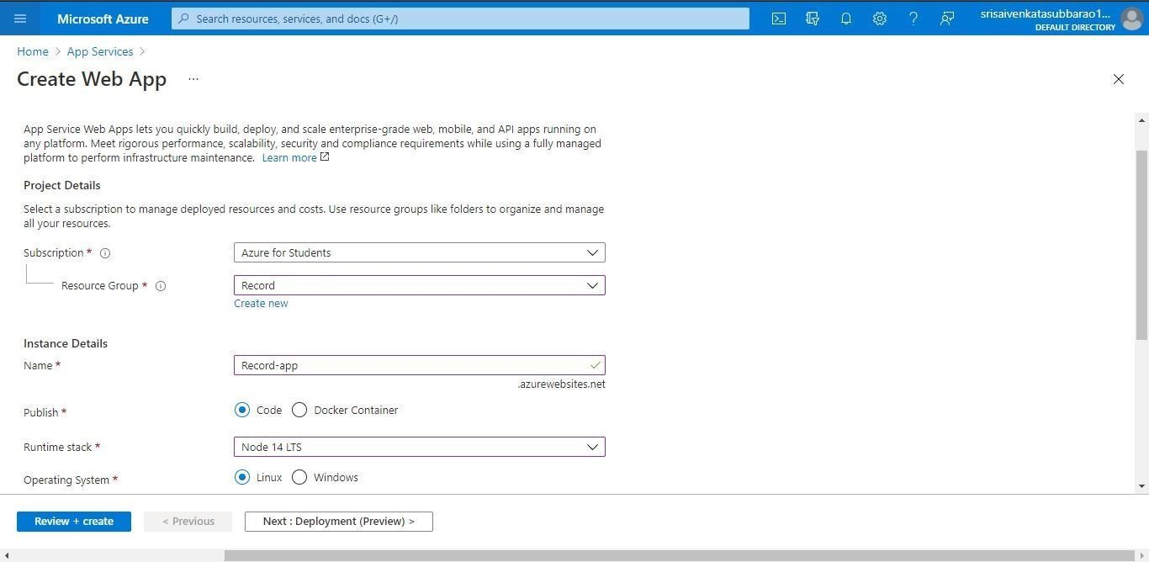

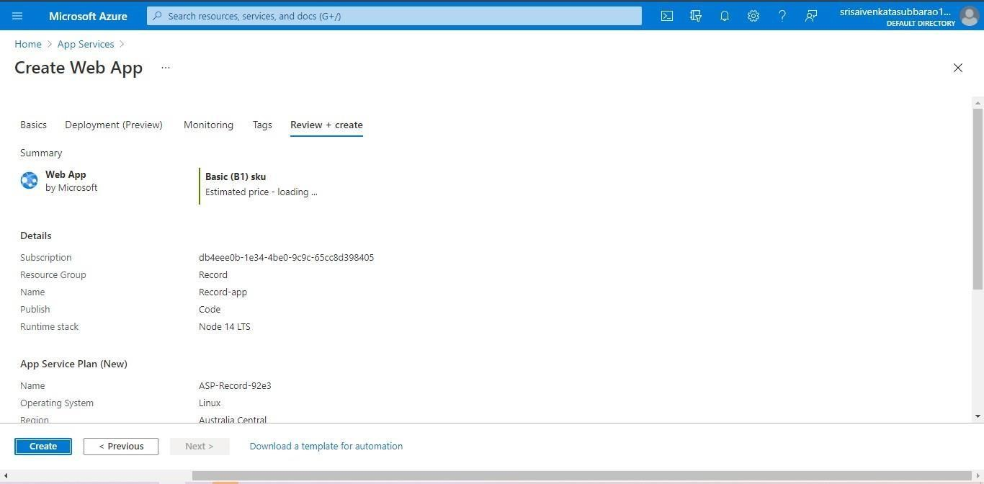

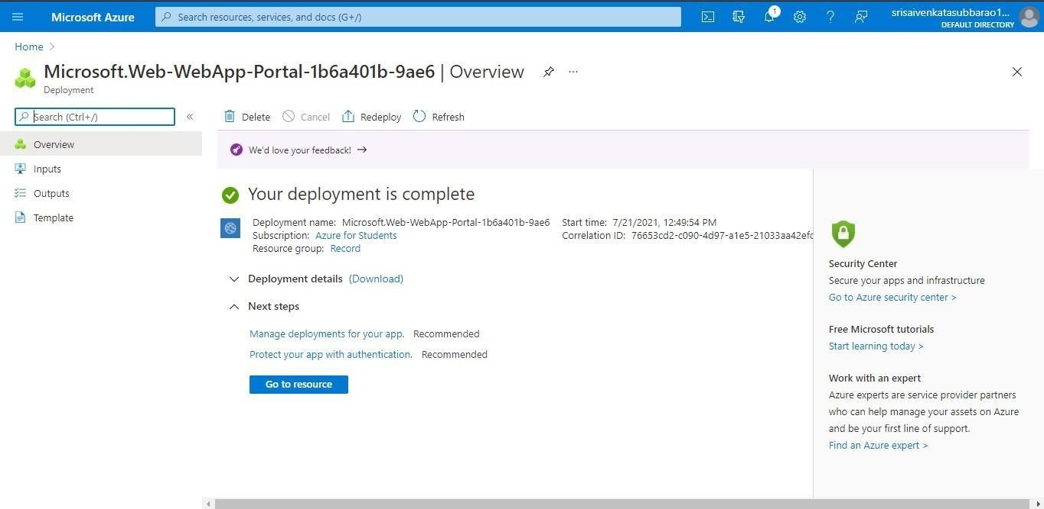

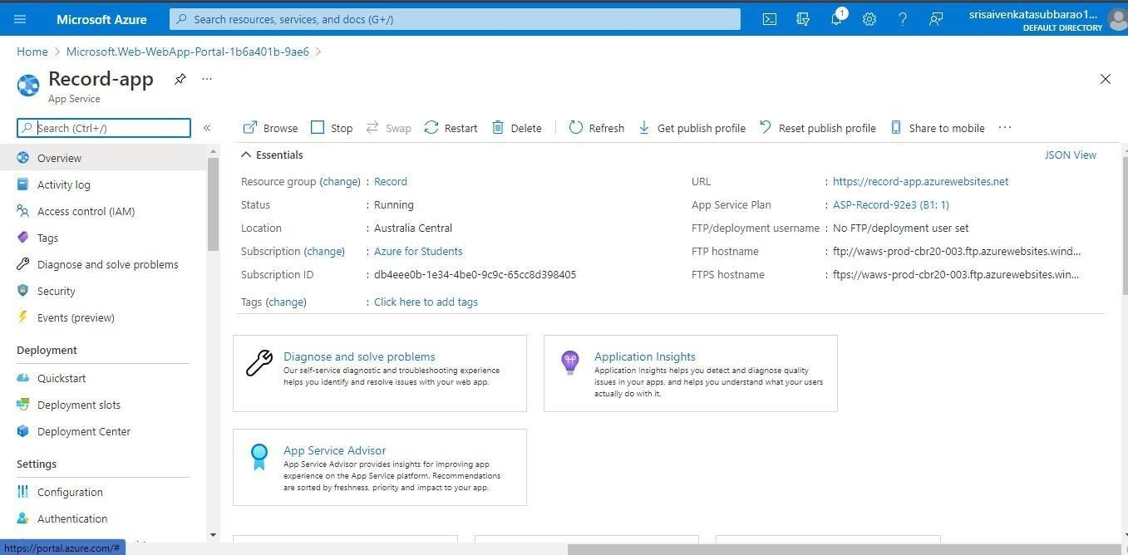

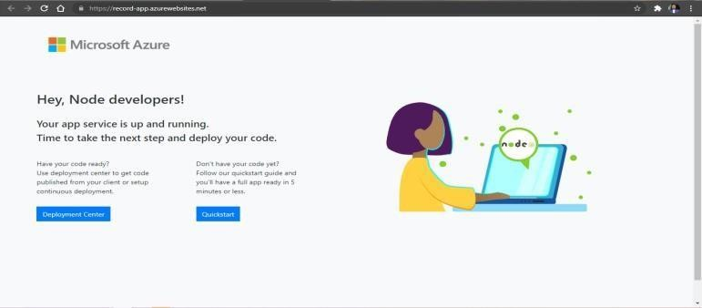

**EXP 17 .DEMONSTRATE INFRASTRUCTURE AS A SERVICE(IAAS) BY**

**CREATING AVIRTUAL MACHINE USING A PUBLIC CLOUD SERVICE PROVIDER(AZURE/GCP/AWS) CONFIGURE WITH MINIMUM CPU, RAM ANDSTORAGE AND LAUNCH THE VM IMAGE.**

**Date:19-09-2024 AIM:**

To demonstrate infrastructure as a service(iaas) by creating a virtual machine using a public cloud service provider(azure/gcp/aws) configure with minimum cpu,ram and storage and launch the vm image.

**Screenshots and Outputs:**













**EXP19.CREATE A STORAGE SERVICE USING ANY PUBLIC CLOUD SERVICE PROVIDER (AZURE/GCP/AWS) AND CHECK THE PUBLIC ACCESSIBILITY OFTHE STORED FILE TO DEMONSTRATE STORAGE AS A SERVICE.**

**DATE: 20-09-2024**

**AIM: to create a storage service using any public cloud service provider (azure/gcp/aws) and check the public accessibility ofthe stored file to demonstrate storage as a service.**

**Screenshots and outputs:**

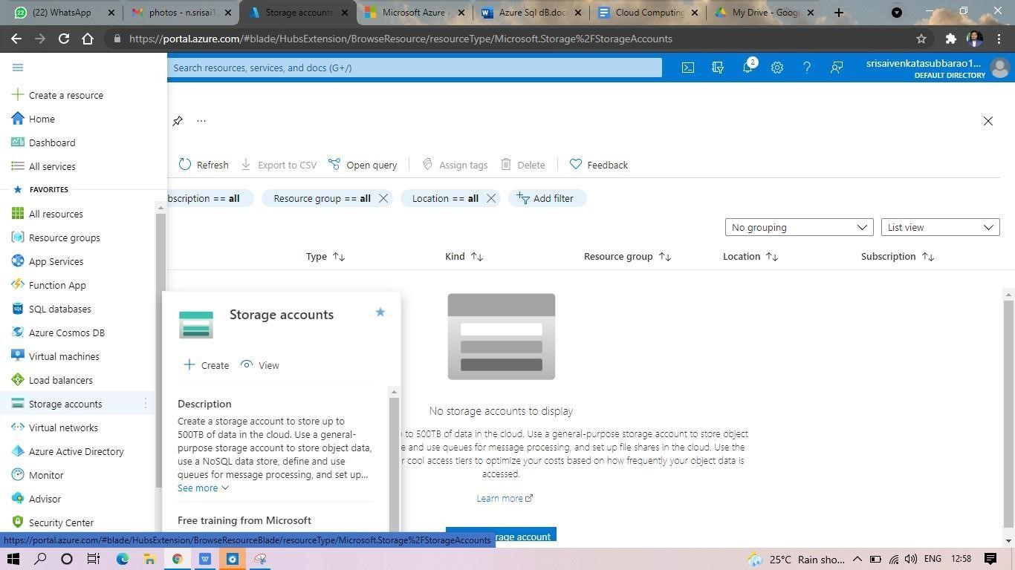

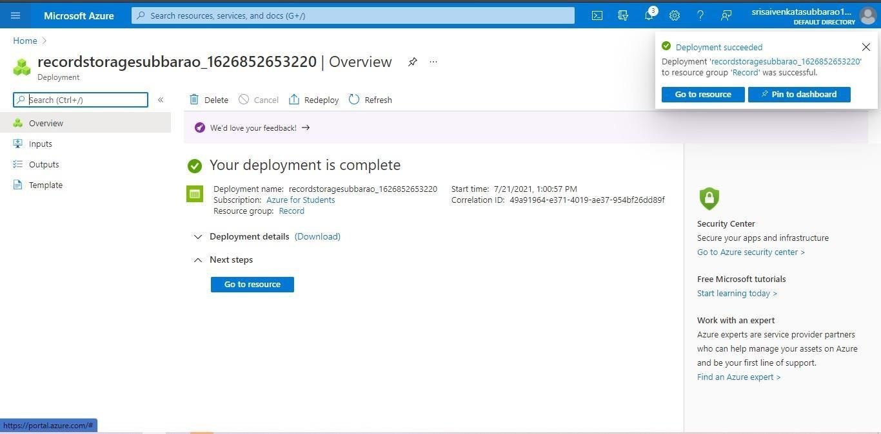

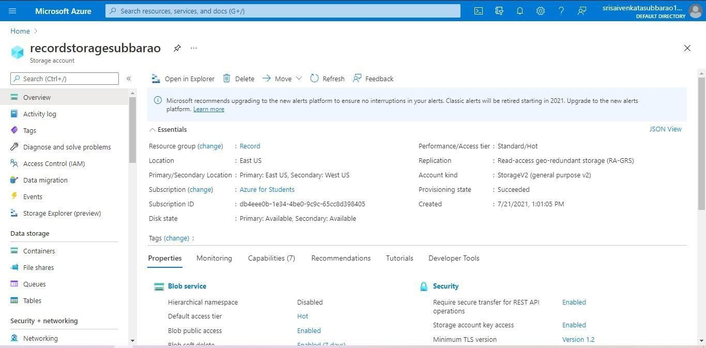

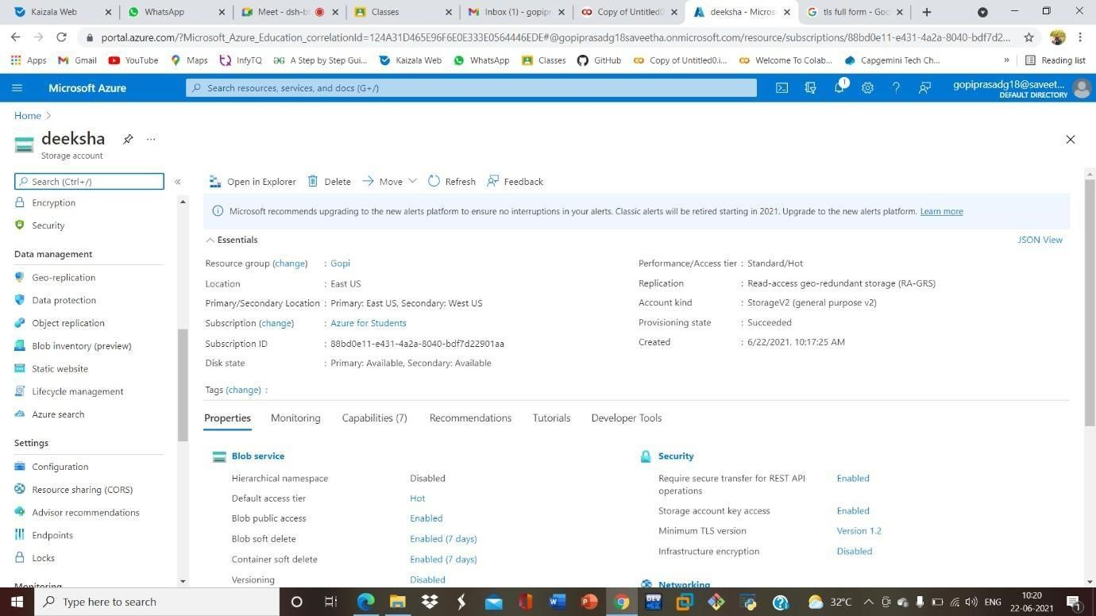

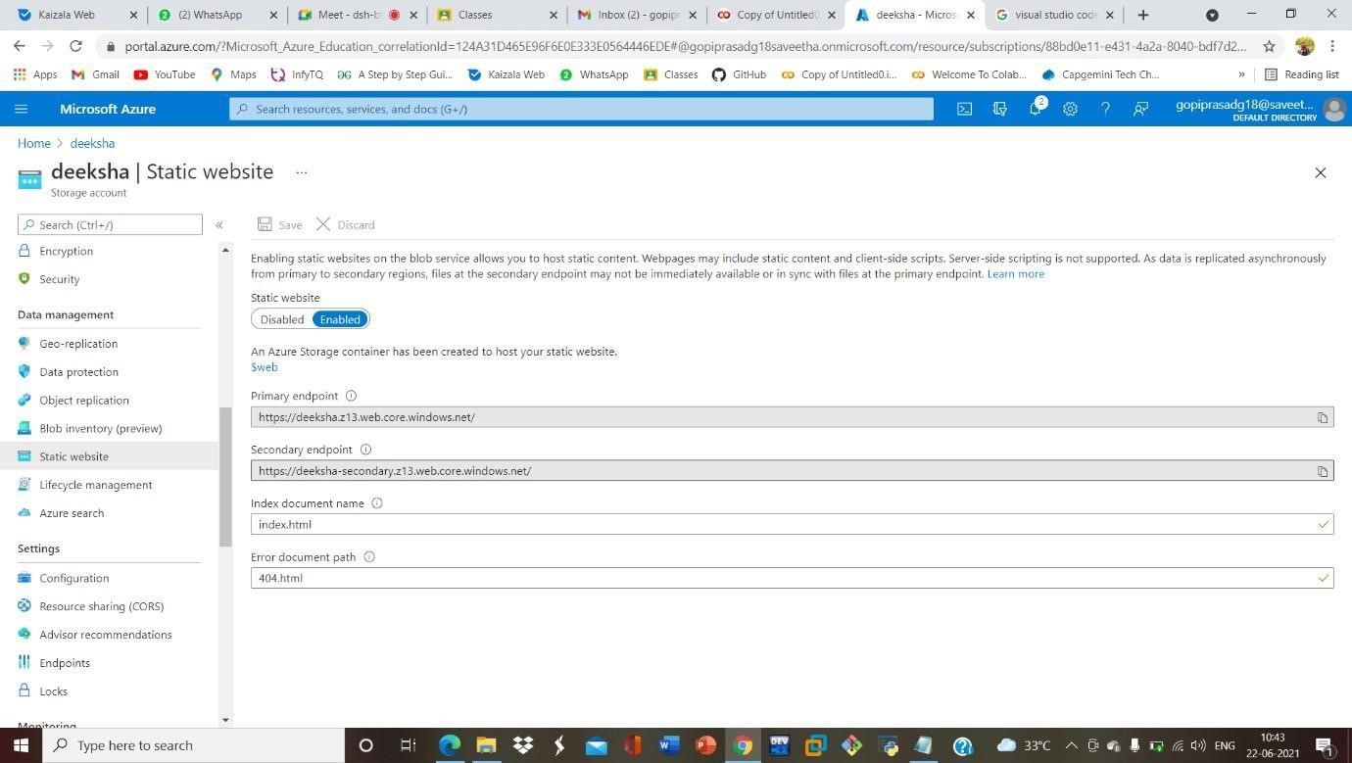

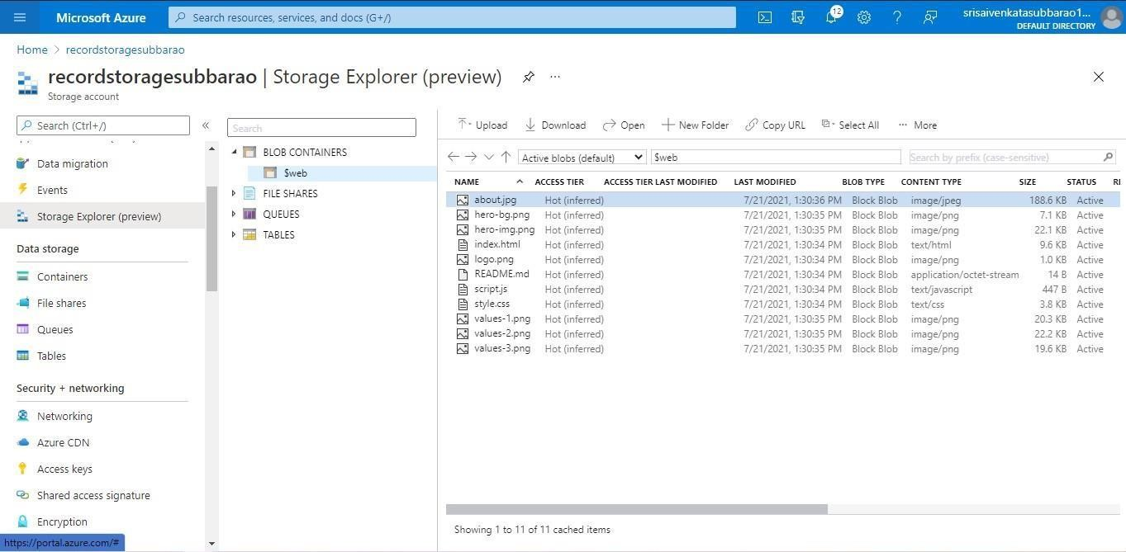

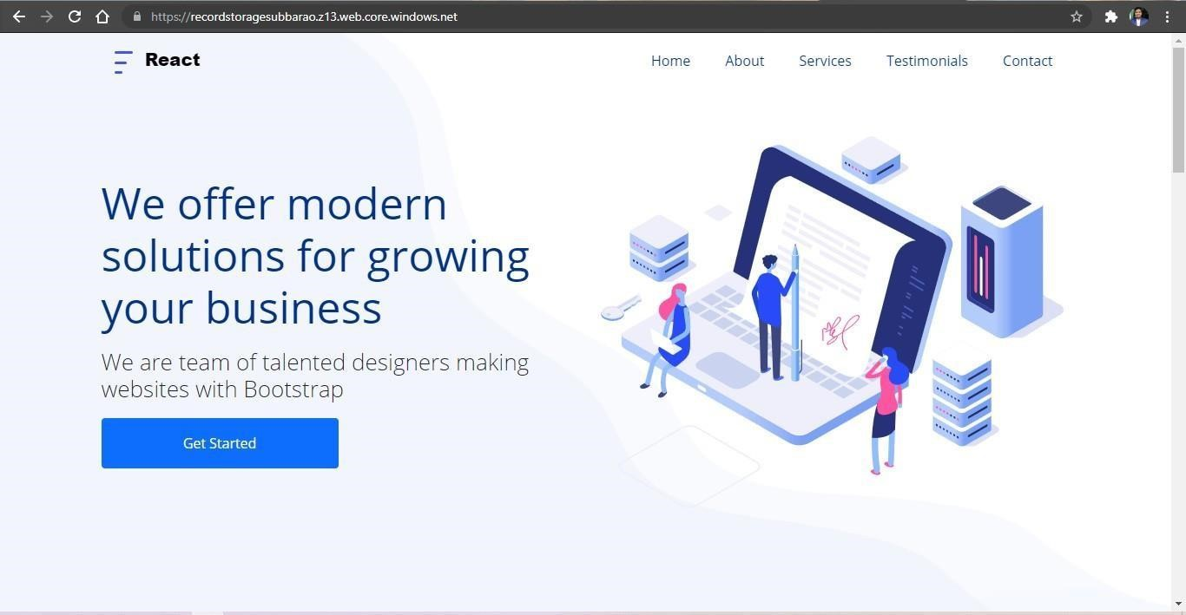

**EXP20.CREATE A SQL STORAGE SERVICE AND PERFORM A BASIC QUERY USINGANY PUBLIC CLOUD SERVICE PROVIDER (AZURE/GCP/AWS) TO DEMONSTRATE DATABASE AS A SERVICE (DAAS) Date:20-09-2024**

**AIM:** CREATE A SQL STORAGE SERVICE AND PERFORM A BASIC QUERY USINGANY PUBLIC CLOUD SERVICE PROVIDER (AZURE/GCP/AWS) TO DEMONSTRATE DATABASE AS A SERVICE (DAAS)

**Screenshots and outputs:**

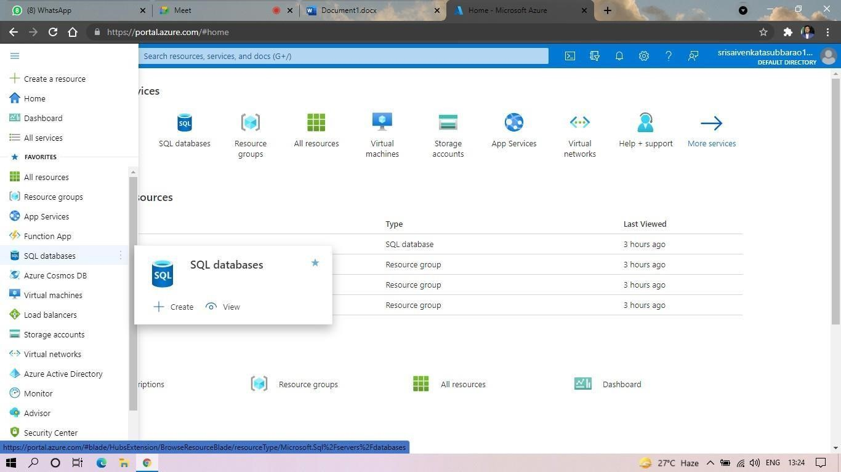

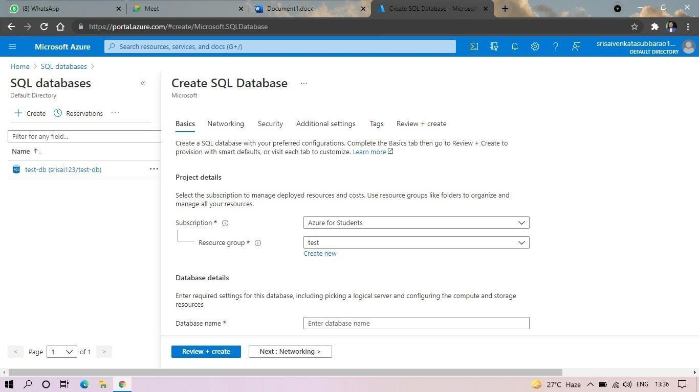

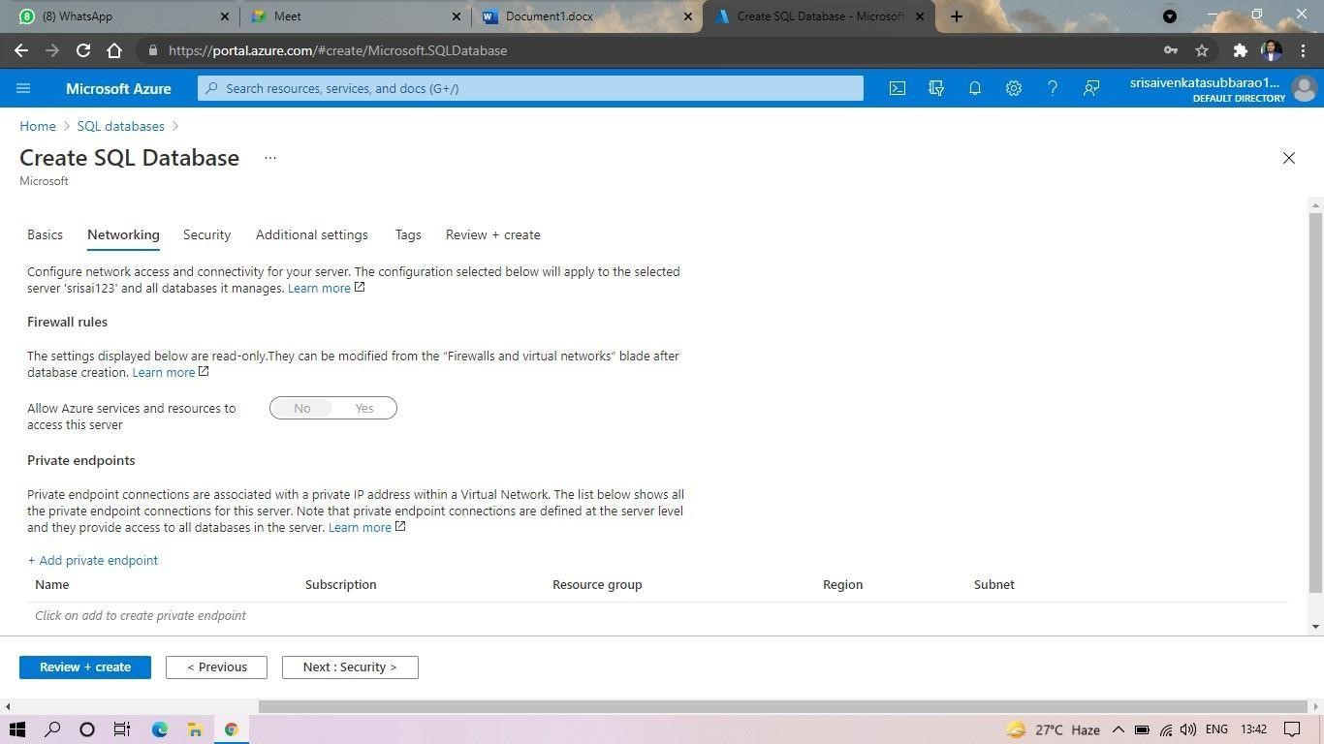

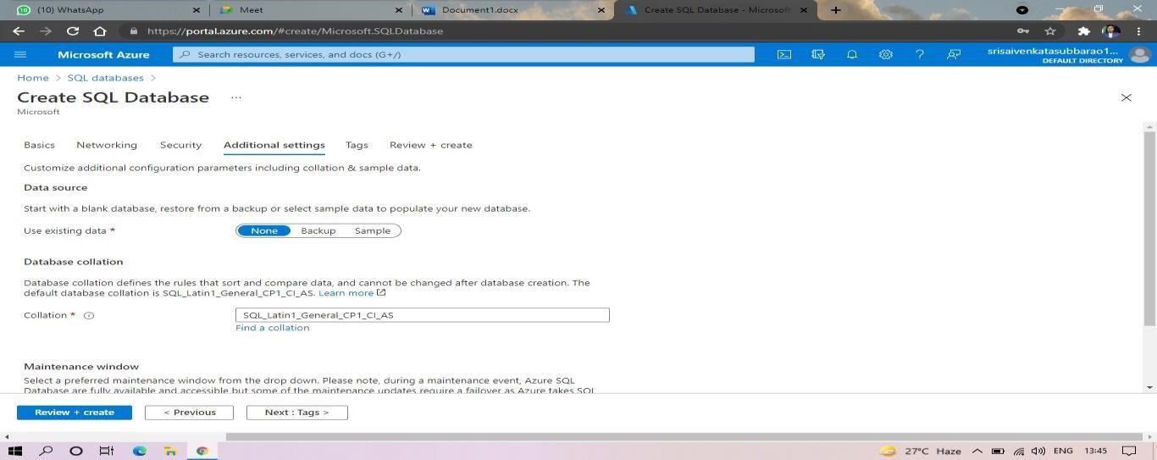

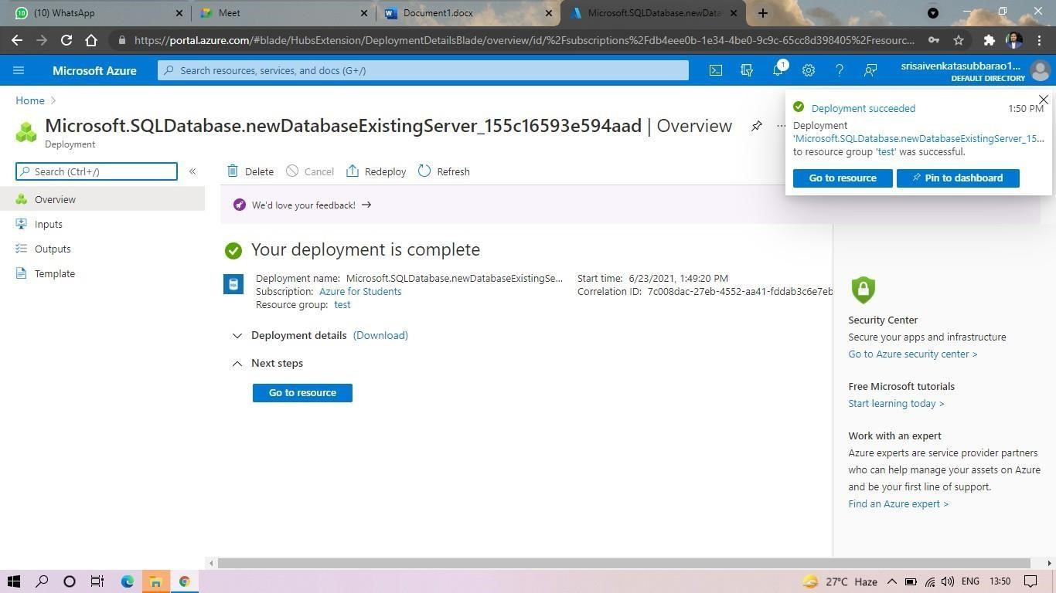

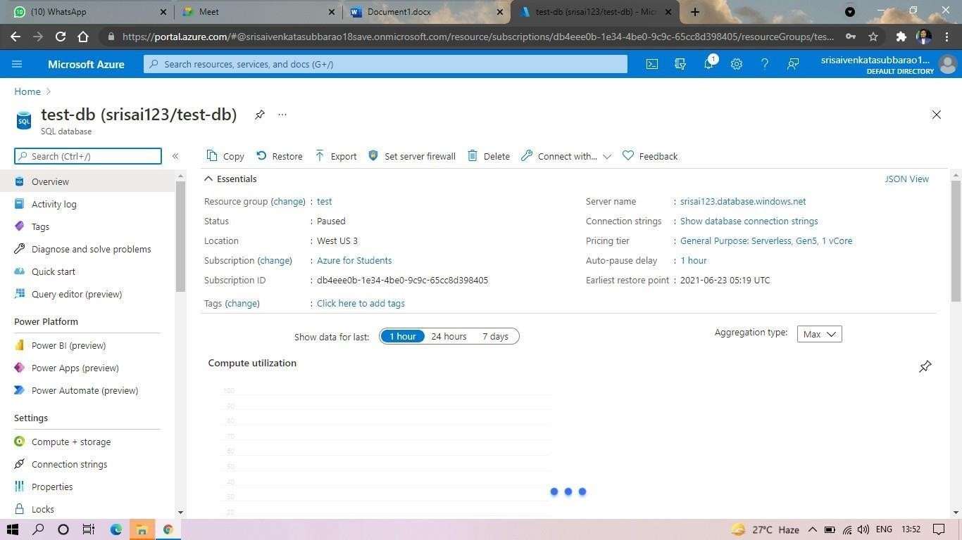

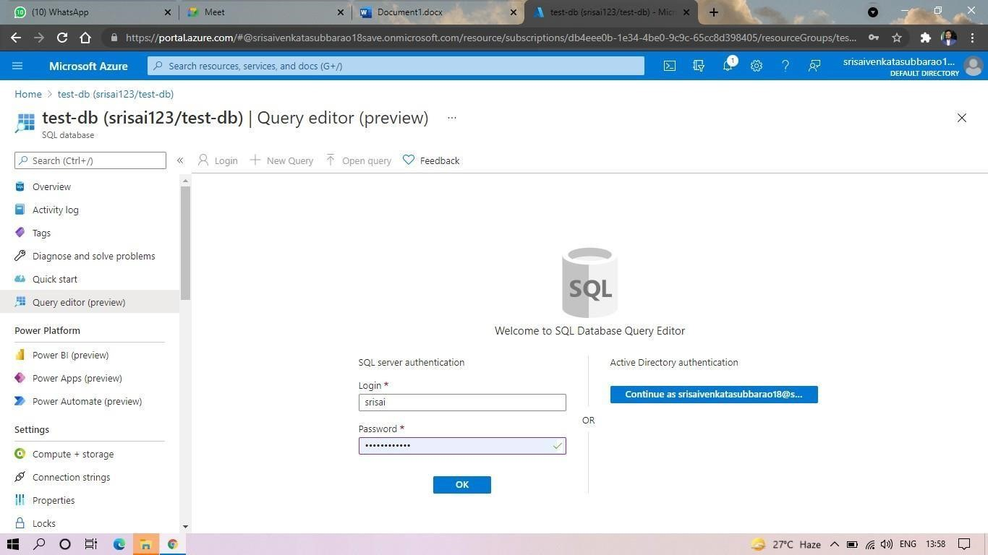

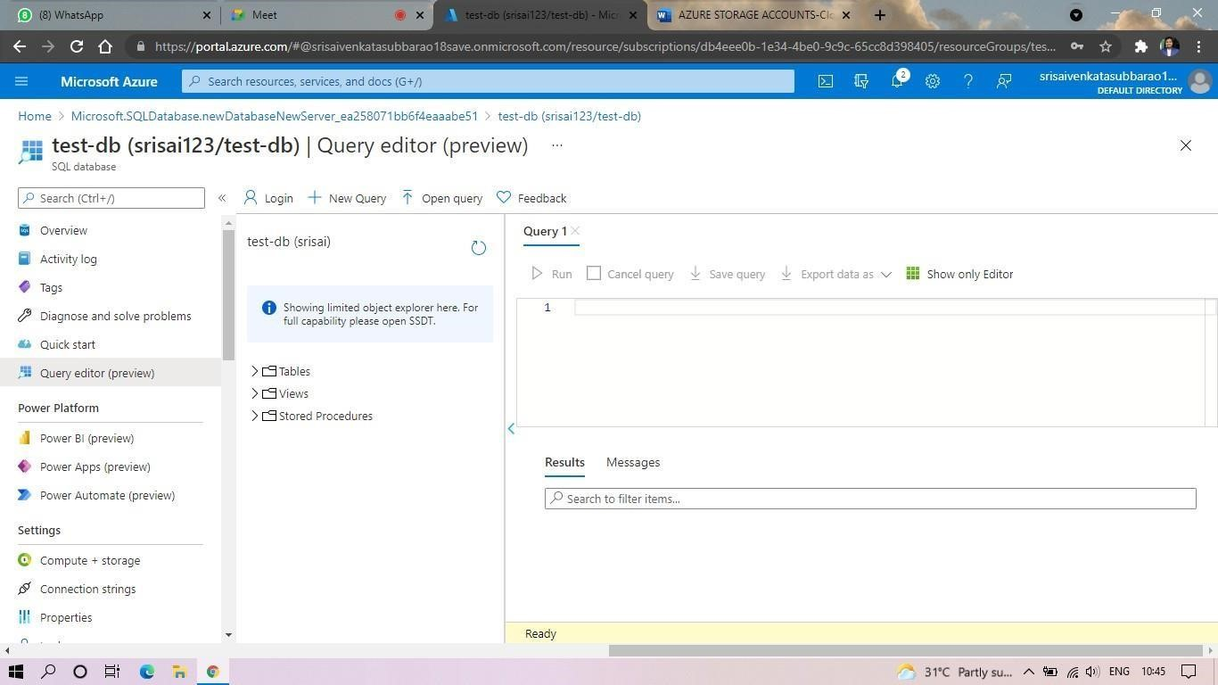

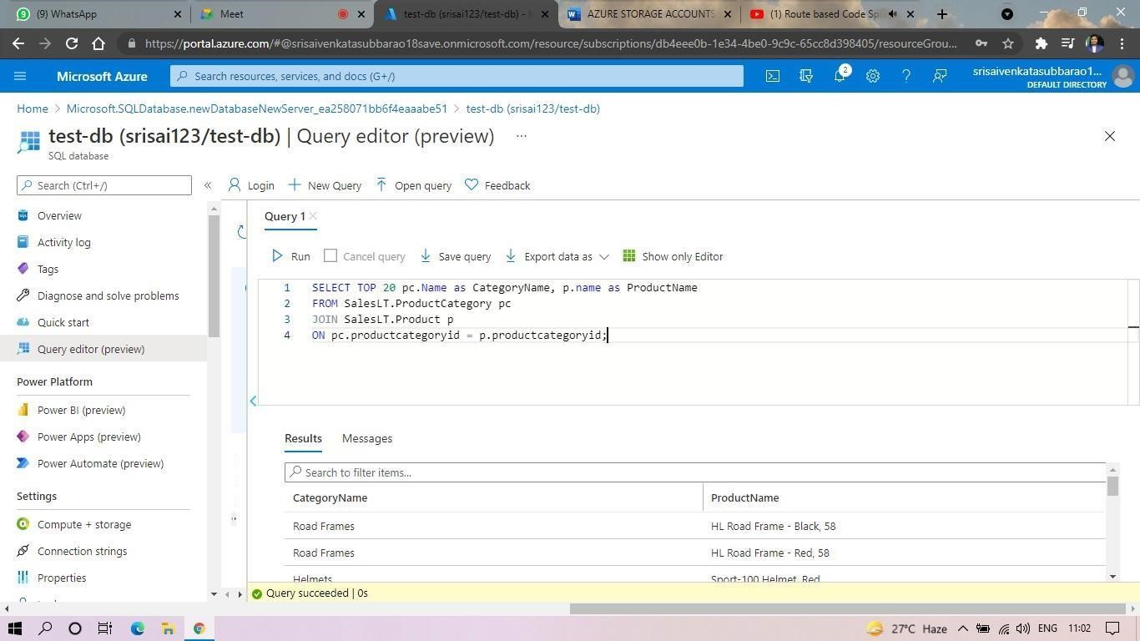

**EXP. 22: PERFORM THE BASIC CONFIGURATION SETUP FOR INSTALLINGHADOOP 2.X LIKE**

**CREATING THE HDUSER AND SSH LOCALHOST**

**Date:21-09-2024**

**AIM:** PERFORM THE BASIC CONFIGURATION SETUP FOR INSTALLINGHADOOP 2.X LIKE CREATING THE HDUSER AND SSH LOCALHOST

**Screenshots and Outputs:**

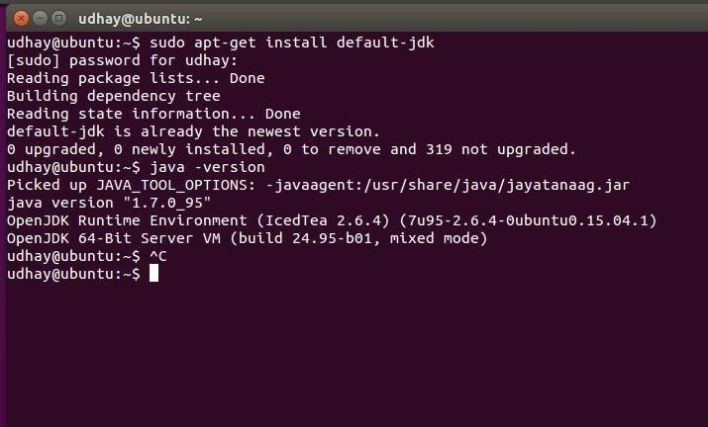

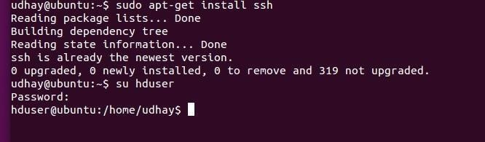

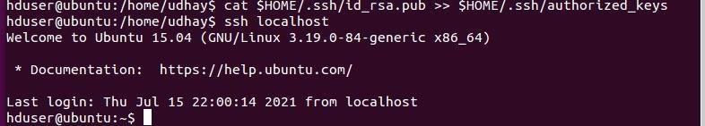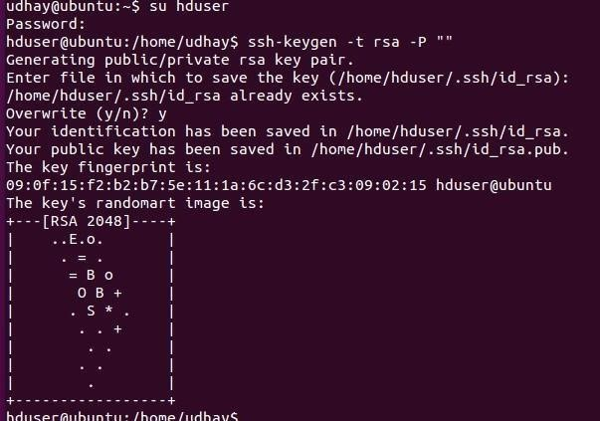

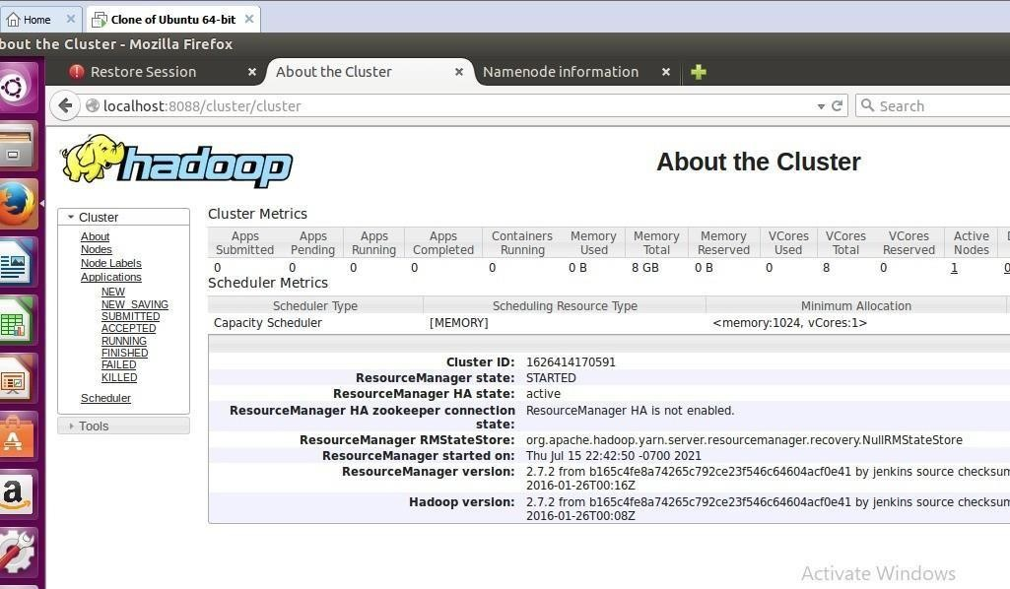

**EXP. 23: INSTALL HADOOP 2.X AND CONFIGURE THE NAME NODE AND DATANODE**. **Date**:21-09-2024

**AIM:** INSTALL HADOOP 2.X AND CONFIGURE THE NAME NODE AND DATANODE.

**Screenshots and Outputs:**

|  |
| --- |
| export JAVA_HOME=/usr/lib/jvm/java-8-oracle export HADOOP_HOME=/usr/local/hadoop/hadoop-2.7.2 export PATH=$PATH:$HADOOP_HOME/bin export PATH=$PATH:$HADOOP_HOME/sbin export HADOOP_MAPRED_HOME=$HADOOP_HOME export HADOOP_COMMON_HOME=$HADOOP_HOME export HADOOP_HDFS_HOME=$HADOOP_HOME export YARN_HOME=$HADOOP_HOME  HADOOP_COMMON_LIB_NATIVE_DIR=$HADOOP_HOME/lib/native export HADOOP_OPTS="-D.java.library.path=$HADOOP_HOME/lib" export PATH=$PATH:/usr/local/hadoop/hadoop-2.7.2/bin |

# The java implementation to use. export JAVA_HOME=/usr/lib/jvm/java-8-oracle <configuration>

<property>

<name>dfs.replication</name>

<value>1</value>

</property>

<property>

<name>dfs.namenode.name.dir</name>

<value>file:/usr/local/hadoop_tmp/hdfs/namenode</value>

</property>

<property>

<name>dfs.datanode.data.dir</name>

<value>file:/usr/local/hadoop_tmp/hdfs/datanode</value>

</property>

</configuration>

<configuration>

<property>

<name>fs.default.name</name>

<value>hdfs://localhost:9000</value>

</property>

</configuration>

<configuration>

<property>

<name>yarn.nodemanager.aux-services</name>

<value>mapreduce_shuffle</value>

</property>

<property>

<name>yarn.nodemanager.aux-services.mapreduce.shuffle.class</name>

<value>org.apache.hadoop.mapred.Shuffle-Handler</value>

</property>

</configuration>

<configuration>

<property>

<name>mapreduce.framework.name</name>

<value>yarn</value>

</property>

</configuration>

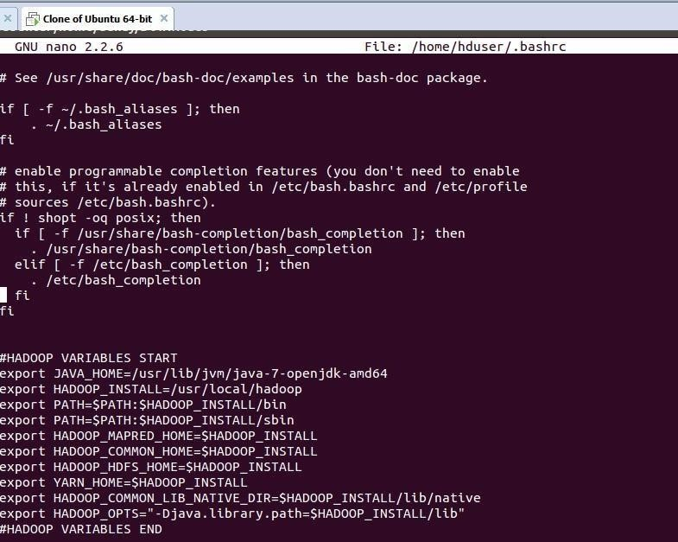

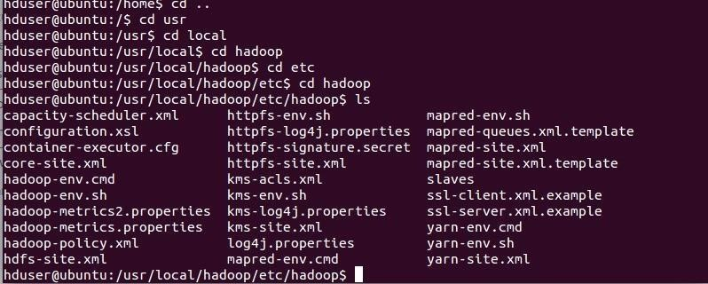

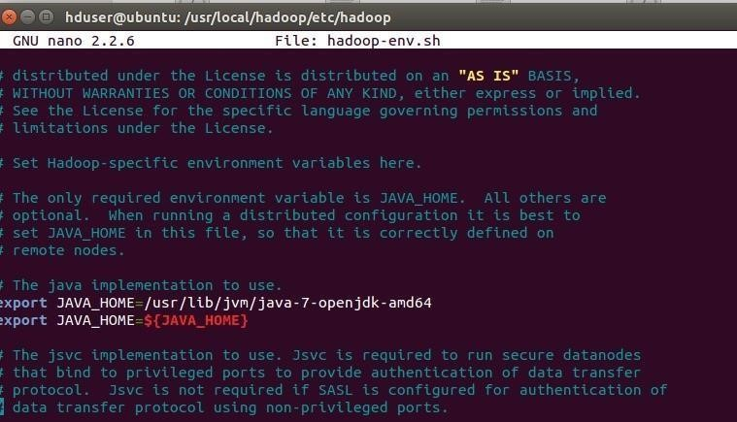

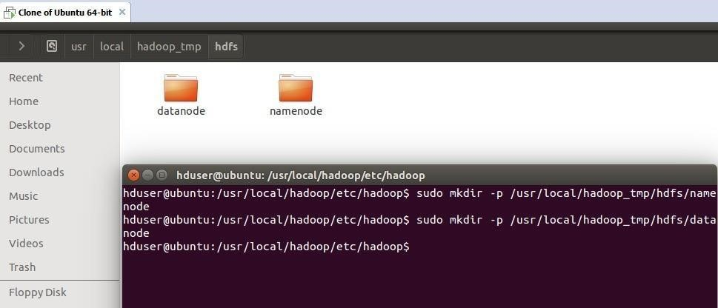

**EXP. 24:** LAUNCH THE HADOOP 2.X AND PERFORM MAPREDUCE PROGRAMFOR A WORD

COUNT PROBLEM

**Date:**23-09-2024

**AIM:** LAUNCH THE HADOOP 2.X AND PERFORM MAPREDUCE PROGRAMFOR A WORD COUNT PROBLEM

**Screenshots and Outputs:**

|  |
| --- |
| import org.apache.hadoop.conf.Configured; import org.apache.hadoop.fs.Path; import org.apache.hadoop.io.IntWritable;  import org.apache.hadoop.mapred.FileInputFormat; import  org.apache.hadoop.mapred.FileOutputFormat;import org.apache.hadoop.mapred.JobClient; import org.apache.hadoop.mapred.JobConf;    import org.apache.hadoop.util.Tool;  import org.apache.hadoop.util.ToolRunner; import org.apache.hadoop.io.Text;    public class WordCount extends Configured implements Tool {@Override  public int run(String[] arg0) throws Exception {  // TODO Auto-generated method stubif(arg0.length<2)  { |

|  |  |
| --- | --- |
| }  } | |
| import java.io.IOException;    import org.apache.hadoop.io.IntWritable; import org.apache.hadoop.io.LongWritable;  import  org.apache.hadoop.mapred.MapReduceBase; import  org.apache.hadoop.mapred.OutputCollector; import org.apache.hadoop.mapred.Reporter; import org.apache.hadoop.io.Text; import org.apache.hadoop.mapred.Mapper;    public class WordCountMapper extends MapReduceBase implements Mapper<LongWritable,Text,Text,IntWritable>  {  @Override  public void map(LongWritable arg0, Text arg1, OutputCollector<Text, IntWritable> arg2,  Reporter arg3) | |

|  |
| --- |
| import java.io.IOException;import java.util.Iterator;  import org.apache.hadoop.io.IntWritable; import org.apache.hadoop.mapred.JobConf;  import org.apache.hadoop.mapred.OutputCollector; import org.apache.hadoop.mapred.Reducer;  import org.apache.hadoop.mapred.Reporter; import org.apache.hadoop.io.Text;    public class WordCountReducer implements Reducer<Text,IntWritable,Text,IntWritable> {  @Override public void configure(JobConf arg0) { |

|  |
| --- |
| }  @Override  public void reduce(Text arg0, Iterator<IntWritable> arg1, OutputCollector<Text, IntWritable>  arg2, Reporter arg3)  throws IOException {  // TODO Auto-generated method stubint count=0; while(arg1.hasNext())  {  IntWritable i=arg1.next(); count+=i.get(); |

